Pre-AP Geometry Name:_______________________
Date:______________Period:____

First Six Weeks Test 2

Non-Calculator. Show work to receive full credit.

1. Identify the symbolic argument
a. | Modus Ponens | c. | Law of Contrapositve
b. | Modus Tollens | d. | Law of Syllogism
e. Not Valid

2. Identify the conclusion of the statement Jack will go to school if today is Monday.
a. | Jack will go to school | c. | today is Monday
b. | Jack will not go to school | d. | today is not Monday

3. Identify the contrapositive of the following statement.
If x 2, then x 3 5.
a. | If x 3 5, then x 2. | c. | If x 2, then x 3 5.
b. | If x 3 5, then x 2. | d. | x 2 and x 3 5.

4. Choose the property that justifies the following statement.
If x 2 and x y 3, then 2 y 3.
a. | Reflexive | c. | Transitive
b. | Symmetric | d. | Substitution

5. Choose the property that justifies the statement mA mA.
a. | Reflexive | c. | Transitive
b. | Symmetric | d. | Substitution

6. Choose the property that justifies the statement If GH FD, then FD GH.
a. | Reflexive | c. | Transitive
b. | Symmetric | d. | Definition of congruent segments

Use the figure below for problem 7.

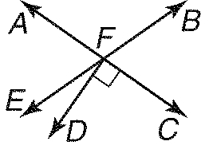

7. If mBFC 70, find mEFD.
a. | 10 | c. | 35
b. | 20 | d. | 70

Use the figures below for problems 8 and 9.

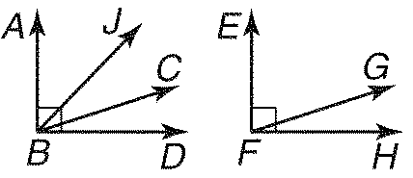

8. If ABCEFG, and mABC 72, find mGFH.
a. | 18 | c. | 90
b. | 72 | d. | 108

9. If mABJ 28, ABC DBJ, find mJBC.
a. | 90 | c. | 45
b. | 56 | d. | 34

10. Identify the inverse of the statement.
If x 5, then x 8 13.
a. | If x 8 13, then x 5. | c. | If x 8 13, then x 5.
b. | x 5 and x 8 13. | d. | If x 5, then x 8 13.

11. Which law can be used to determine that statement (3) is a valid conclusion to statements (1) and (2)?
(1) All dogs like biscuits.
(2) Sammy is a dog.
(3) Sammy likes biscuits.

a. | Law of Detachment | c. | Law of Converse
b. | Law of Syllogism | d. | Statement (3) does not follow.

12. Choose the property that justifies the statement.
If x y and y z, then x z.
a. | Conditional | c. | Symmetric
b. | Transitive | d. | Reflexive

13. Choose the property that justifies the following statement.
If 3AB CD, then AB CD.
a. | Addition | c. | Division
b. | Subtraction | d. | Substitution

14. Identify the symbolic argument
a. | Modus Ponens | c. | Law of Contrapositve
b. | Modus Tollens | d. | Law of Syllogism
e. Not Valid

15. Identify the symbolic argument
a. | Modus Ponens | c. | Law of Contrapositve
b. | Modus Tollens | d. | Law of Syllogism
e. Not Valid

16. Identify the symbolic argument
a. | Modus Ponens | c. | Law of Contrapositve
b. | Modus Tollens | d. | Law of Syllogism
e. Not Valid

17. Given: XY YZ
Conjecture: Y is a midpoint of XZ.
Evaluate if the conjecture is true or false. If false, provide a counterexample.

18. If m1 x 50 and m2 3x 20, find m1.

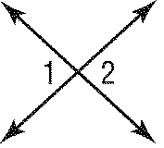
19. Complete the proof below by supplying the reasons for each location.
Given: 3 2(4 x) 11 6x
Prove: x 4
Statements | Reasons
1. 3 2(4 x) 11 6x | 1. Given
2. 3 8 2x 11 6x | 2. ____________________
3. 5 2x 11 6x  4. | 3. ____________________  4. ____________________
5. 2x 16 6x | 5._____________________
6. | 6._____________________
7. 4x 16  8. | 7._____________________  8._____________________
9. x 4 | 9._____________________

20. Given: and intersect at point X;;.
Prove:
Proof:
Statements | Reasons
1. ; | 1. Given
2. | 2. _______________________
3. | 3. _______________________
4. _________________________ | 4. Substitution Prop.
5. | 5. Subtraction Prop.
6. _________________________  7.  8.  9._________________________  10. | 6. Substitution Prop.  7. _______________________  8. _______________________  9. Division Prop.  10. Substitution Prop.

21. Complete the truth table.

P | Q | R | ~P | ~R

22. All sides of an equilateral triangle have the same length of 1 unit.

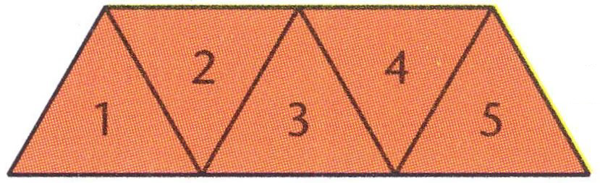

(a) What is the perimeter when 3 equilateral triangles are pushed together?

(b) What is the perimeter when 5 equilateral triangles are pushed together?

(c) What is the perimeter when 100 equilateral triangles are pushed together?

23. Look at the number pattern below.

(a) What is the sum of the first 10 odd numbers?

(b) Make a conjecture about the sum of the first n odd numbers.

