Pre-AP Geometry Name:_________________

Points:____ Date:________

**First Six Weeks, Test 1 Retest**

**Non-Calculator. Make sure to show all of your work**

Multiple Choice

____ 1. Find the distance between P(2, 8) and Q(5, 3).

|  |  |  |  |
| --- | --- | --- | --- |
| a. | 9 | c. |  |
| b. |  | d. |  |

____ 2. Find the coordinates of the midpoint of LB if L(8, 5) and B(–6, 2).

|  |  |  |  |
| --- | --- | --- | --- |
| a. |  | c. |  |
| b. |  | d. |  |

Use the figure below.

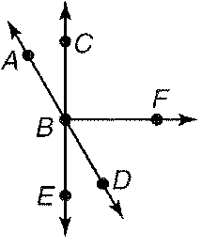

____ 3. Find mFBD if FBD and DBE are complementary and mFBD is twice

mDBE.

|  |  |  |  |
| --- | --- | --- | --- |
| a. | 30 | c. | 60 |
| b. | 45 | d. | 90 |

____ 4. Which pair of angles are supplementary?

|  |  |  |  |
| --- | --- | --- | --- |
| a. | ABE, CBD | c. | ABC, CBD |
| b. | ABC, ABD | d. | ABC, EBD |

____ 5. Which angle is a vertical angle to ABE?

|  |  |  |  |
| --- | --- | --- | --- |
| a. | DBE | c. | ABC |
| b. | CBD | d. | EBA |

____ 6. If mCBF  6x  18, find x so that CB  BF.

|  |  |  |  |
| --- | --- | --- | --- |
| a. | 90 | c. | 18 |
| b. | 45 | d. | 12 |

____ 7. Find mABC if mABC  4x  9 and mEBD  7x  9.

|  |  |  |  |
| --- | --- | --- | --- |
| a. | 6 | c. | 45 |
| b. | 33 | d. | 73 |

____ 8. Find x if S is between R and T, RS is x  3, ST is 5x, and RT is 57.

|  |  |  |  |
| --- | --- | --- | --- |
| a. | 9 | c. | 10.8 |
| b. | 10 | d. | 12 |

In the figure,  bisects .



____ 9. If  and  , find x.

|  |  |  |  |
| --- | --- | --- | --- |
| a. | 33 | c. | 11 |
| b. | 58 | d. | 29 |

____ 10. The measures of two complementary angles are  and  . Find the measures of the angles.

|  |  |  |  |
| --- | --- | --- | --- |
| a. | 42, 48 | c. | 8.75 |
| b. | 4.25 | d. | 96, 84 |

____ 11. Find the length of BC.

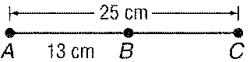

|  |  |  |  |
| --- | --- | --- | --- |
| a. | 12 cm | c. | 25 cm |
| b. | 13 cm | d. | 38 cm |

Free Response

Use the coordinate grid.

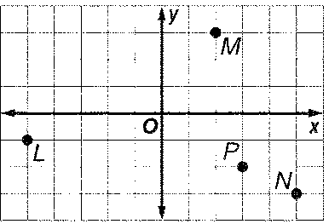

12. Find the distance between L and M.

13. Find the coordinates of the midpoint of M N.

14. Find the coordinates of a point Q if P is the midpoint of NQ.

15. The vertices of a triangle are located at P(0, 6), Q(8, -1), and R(3, 3). What is the perimeter of this triangle?