**Study Guide and Intervention**

***Adding and Subtracting Polynomial Functions***

 Write polynomial representations for *B*(*x*), the area of the base of the triangular prism, *L*(*x*), the lateral surface area of the triangular prism, and *T*(*x*), the total surface area of the triangular prism. Add the polynomial functions to show that *T*(*x*) = 2*B*(*x*) + *L*(*x*).

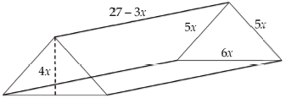

**Solution**

**Step 1** Use the information in the figure to write a function, ***B***(***x***), which represents the area of the base of the triangular prism.

*A* = $\frac{1}{2}$*lw*

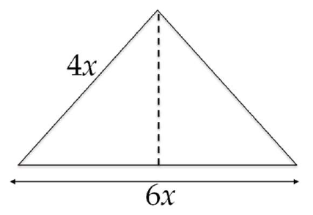*B*(*x*) = $\frac{1}{2}$ (6*x*)(4*x*)

*B*(*x*) = (24*x*2)

*B*(*x*) = 12*x*2

**Step 2** Use the information in the figure to write a function, ***L***(***x***), which represents the lateral surface area of the triangular prism.

*L* = *Ph*

*L*(*x*) = (5*x* + 5*x* + 6*x*)(27 – 3*x*)

*L*(*x*) = (16*x*)(27 – 3*x*)

*L*(*x*) = 432*x* – 48*x2*

*L*(*x*) = –48*x2* + 432*x*

**Step 3** Create a table of values for the total surface area of the triangular prism. Use finite differences in the table, including working backwards to find a zero term, to determine ***T***(***x***), a function that represents the total surface area of the triangular prism.

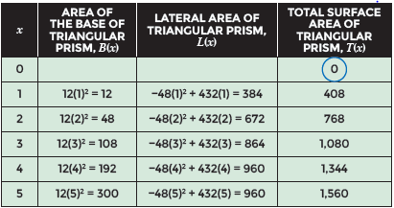

**Step 4** Add 2***B***(***x***) + ***L***(***x***). Compare the sum to ***T*** (***x***).

2*B*(*x*) + *L*(*x*) = 2[12*x*2] + [– 48*x*2 + 432*x*]

2*B*(*x*) + *L*(*x*) = 24*x*2 – 48*x*2 + 432*x*

2*B*(*x*) + *L*(*x*) = –24*x*2 + 432*x*

Therefore, *T*(*x*) = 2*B*(*x*) + *L*(*x*).

**Exercises**

**For questions 1-4, use the table.**

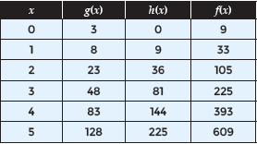

**1.** Determine the function rule for *g*(*x*).

**3.** Determine the function rule for *f*(*x*).

**2.** Determine the function rule for *h*(*x*).

**4.** Use *g*(*x*), *h*(*x*), and *f*(*x*) to determine whether *f*(*x*) = 3*g*(*x*) + *h*(*x*).

**Study Guide and Intervention**

***Adding and Subtracting Polynomial Functions (cont.)***

**Exercises**

**Use the diagram of the triangular prism to complete questions 5 – 7.**

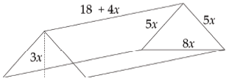

**5.** Complete the table to show the area of the base, the lateral area, and the total surface area of the triangular prism above, for various values of *x*.

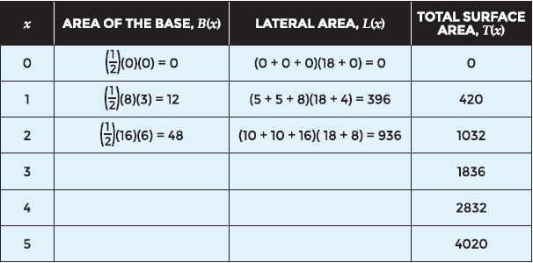

**6.** Write polynomial representations for *B*(*x*), the area of the base of the triangular prism, *L*(*x*), the lateral surface area of the triangular prism, and *T*(*x*), the total surface area of the triangular prism.

**7.** Use your function representations to verify that *T*(*x*) = 2*B*(*x*) + *L*(*x*).

**Use the information below to complete problems 8 – 10.**

Gabe is painting a wall in his house. It is shaped like a rectangle with a trapezoid on top. The table shows the area of each part of the wall, and the total area, for various values of *n*.

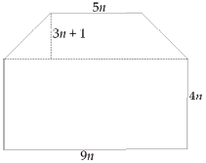

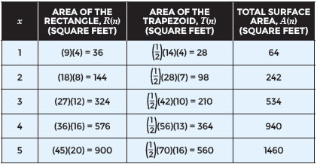

**8.** Use the table to write polynomial functions for the area of each part of the wall, and the total area.

**9.** Use your functions to verify that the total area is equivalent to the sum of each part of the wall.

**10.** If the value of n is 2.5 feet, what is the total area of the wall?

**Study Guide and Intervention**

***Adding and Subtracting Polynomial Functions (cont.)***

**Exercises**

**Use the information below to complete questions 11 – 13.**

Melissa and Kyle are making a bench for their yard. They plan to use several wood boxes, as shown below.

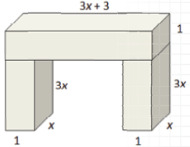

**11.** Use the diagram to write polynomial functions for the volume of each leg, L(x), the volume of the top piece of the bench, T(x), and the total volume of the bench, V(x).

12. Use the functions you generated to show that the total volume of the bench is the sum of the volume of its parts.

**13.** If Melissa and Kyle build a bench leg that has a volume of 0.75 cubic feet, what will be the total volume of the bench?

**Use the information below to complete questions 14 – 16.**

Ramon creates patterns for tile tabletops, as shown.

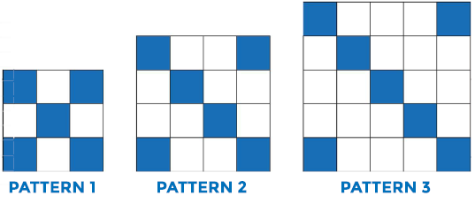

**14.** Use a table to generate function values, look for patterns, and write polynomial functions that describe T(n) the number of total tiles needed for each pattern, and B(n), the number of blue tiles needed for each pattern.

**15.** Use a table to write a polynomial function, W(n), that describes the number of white tiles needed for the nth pattern.

**16.** How many white tiles will Ramon need for the 10th pattern?