Algebraic Reasoning

Name:______________________

Per:_____

POINTS:____

Classwork #35 Quiz

**Be sure to include your work when appropriate.**

**Use the information below to complete questions 1 – 4.**

A cardboard container is constructed by cutting a square out of a rectangular piece of cardboard measuring 20 inches by 40 inches. The sides created are then folded up to form the height of the container.

**1.** Fill in the table of values based on x, the side length of the removed square. The first 2 lines of the table have been completed for you.

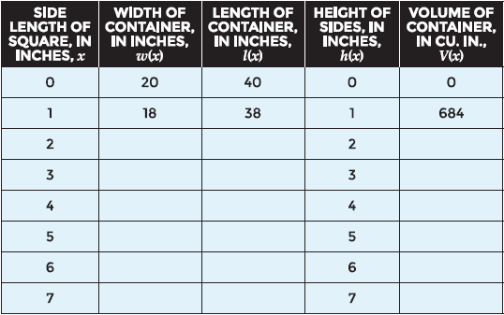

**2.** What type of function is V(x)?

**3.** Write the function V(x).

**4.** Based on the function rule for V(x), what would be the volume of a container if the side length of the removed square is 7.5 inches?

Algebraic Reasoning

Name:______________________

Per:_____

POINTS:____

Classwork #35 Quiz

**Be sure to include your work when appropriate.**

**Use the information below to complete questions 1 – 4.**

A cardboard container is constructed by cutting a square out of a rectangular piece of cardboard measuring 20 inches by 40 inches. The sides created are then folded up to form the height of the container.

**1.** Fill in the table of values based on x, the side length of the removed square. The first 2 lines of the table have been completed for you.



**2.** What type of function is V(x)?

**3.** Write the function V(x).

**4.** Based on the function rule for V(x), what would be the volume of a container if the side length of the removed square is 7.5 inches?

**Use the functions shown to write the simplest of form of the indicated products.**

**a(x) = 2x**

**b(x) = 10 – 2x**

**c(x) = 3x + 12**

**5.** b(x) · c(x)

**6.** a(x) · c(x)

**7.** a(x) · b(x) · c(x)

**Use the functions shown to write the simplest of form of the indicated products.**

**a(x) = 2x**

**b(x) = 10 – 2x**

**c(x) = 3x + 12**

**5.** b(x) · c(x)

**6.** a(x) · c(x)

**7.** a(x) · b(x) · c(x)