Algebraic Reasoning

Name:______________________

Per:_____

POINTS:____

Classwork #34 Quiz

**Be sure to include your work when appropriate.**

**Use the information below to complete questions 1 – 3.**

Melissa and Kyle are making a bench for their yard. They plan to use several wood boxes, as shown below.

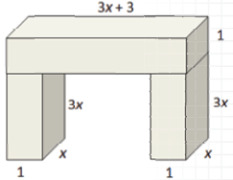

**1.** Use the diagram to write polynomial functions for the volume of each leg, L(x), the volume of the top piece of the bench, T(x), and the total volume of the bench, V(x).

2. Use the functions you generated to show that the total volume of the bench is the sum of the volume of its parts.

**3.** If Melissa and Kyle build a bench leg that has a volume of 0.75 cubic feet, what will be the total volume of the bench?

Algebraic Reasoning

Name:______________________

Per:_____

POINTS:____

Classwork #34 Quiz

**Be sure to include your work when appropriate.**

**Use the information below to complete questions 1 – 3.**

Melissa and Kyle are making a bench for their yard. They plan to use several wood boxes, as shown below.



**1.** Use the diagram to write polynomial functions for the volume of each leg, L(x), the volume of the top piece of the bench, T(x), and the total volume of the bench, V(x).

2. Use the functions you generated to show that the total volume of the bench is the sum of the volume of its parts.

**3.** If Melissa and Kyle build a bench leg that has a volume of 0.75 cubic feet, what will be the total volume of the bench?

**Use the information below to complete questions 4 – 6.**

Ramon creates patterns for tile tabletops, as shown.

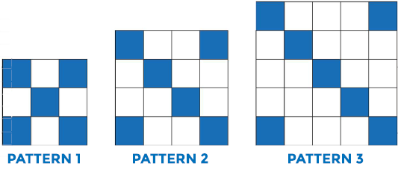

**4.** Use a table to generate function values, look for patterns, and write polynomial functions that describe T(n) the number of total tiles needed for each pattern, and B(n), the number of blue tiles needed for each pattern.

**5.** Use a table to write a polynomial function, W(n), that describes the number of white tiles needed for the nth pattern.

**6.** How many white tiles will Ramon need for the 10th pattern?

**Use the information below to complete questions 4 – 6.**

Ramon creates patterns for tile tabletops, as shown.



**4.** Use a table to generate function values, look for patterns, and write polynomial functions that describe T(n) the number of total tiles needed for each pattern, and B(n), the number of blue tiles needed for each pattern.

**5.** Use a table to write a polynomial function, W(n), that describes the number of white tiles needed for the nth pattern.

**6.** How many white tiles will Ramon need for the 10th pattern?