**Study Guide and Intervention**

***Composing Functions***

 **A wrecking ball with a mass of 2000 kg is released from the top of a 40-meter crane. Using its height at any time before hitting the concrete below, calculate the ball’s gravitational potential energy. Use the function *h*(*t*) = −4.9*t*2 + 40 to determine the height of the wrecking ball as it falls. Use the function *p*(*h*) = *m* · *g* · *h* to calculate its potential energy, where mass m = 2,000 kg, gravity *g* = 9.8 meters per second squared, and the height *h*(*t*) is in meters.**

**Solution**

**STEP 1** Create a table for ***h***(***t***) = −4.9***t***2 + 40 in 0.5 second intervals.

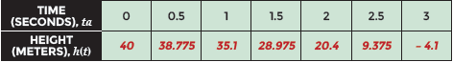

**STEP 2** Create a table for the potential energy ***p***(***h***) = ***m*** · ***g*** · ***h*** of the wrecking ball from the time it is released from the crane until it hits the concrete below.

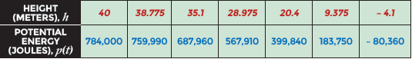

**STEP 3** Combine the tables with the domain for ***h***(***t***) = −4.9***t***2 + 40 and the range for ***p***(***h***) = ***m*** · ***g*** · ***h*** to reflect potential energy with respect to time.

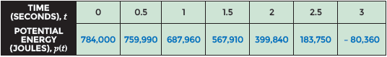

**STEP 4** Write the potential energy function as a composition of the functions for height and potential energy.

p(h) = m · g · h

p(h(t)) = 2000 · 9.8 · (− 4.9**t2** + 40)

p(h(t)) = 19,600(− 4.9t2 + 40)

p(h(t)) = –96,040t2 + 784,000

p(h(t)) can also be written as (p ∘ h)(t).

**Exercises**

**For questions 1 - 6 use the scenario below.**

**A local department store is having a clearance sale and discounting everything in the store by 25%. The sales tax rate is 8.25%.**

**1.** Write a function f(x) to represent the discounted amount of a purchase, x.

**3.** Write a function g(x) to represent the amount of sales tax charged on any purchase, x.

**5.** Write a composition of the functions that can be used to calculate the amount of tax charged on a discounted purchase. Simplify the composition.

**2.** Use the function f(x) to complete the table below. 

**4.** Use the function g(x) to complete the table below. Round to the nearest cent.

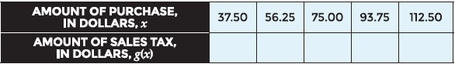

**6.** Use the composition *g*(*f*(*x*)) to calculate the amount of sales tax on the discounted amount of purchase, based on the original cost of the purchase.



**Study Guide and Intervention**

***Composing Functions (cont.)***

**Exercises**

**For questions 7 – 14 use the situation below.**

**The Metro Motorcycle Company is having a year-end sale on five models of motorcycles. They are offering a rebate of $2,000 on each motorcycle sold or a 10% discount on each motorcycle sold.**

**7.** Write a function R(x) to represent the cost of a motorcycle, x, after the rebate.

**9.** Write a function D(x) to represent the cost of a motorcycle, x, after the 10% discount.

**11.** The Metro Motorcycle Company decides to give customers the rebate and the discount on all models of motorcycles. Write the composed function if the company applies the rebate first, and then the discount.

**13.** After several weeks, The Metro Motorcycle Company decides to change the way it calculates the reduced price of its motorcycles by applying the discount first, and then the rebate. Write the composed function representing this situation.

**8.** Use *R*(*x*) to fill in the table of values.

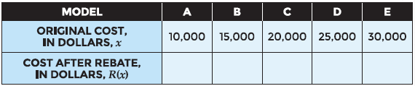

**10.** Use *D*(*x*) to fill in the table of values.

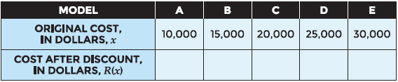

**12.** Fill in the table of values using *D*(*R*(*x*)).

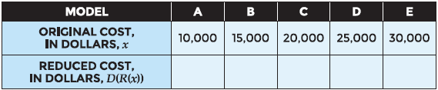

**14.** Fill in the table of values using *R*(*D*(*x*)).

