Algebraic Reasoning

Name:______________________

Per:_____

POINTS:____

Classwork #32 Quiz

**Be sure to include your work when appropriate.**

1. Complete the table for missing h(x) values.

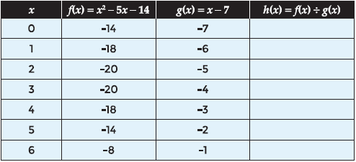

2. Use the table for the function

f(x) = 2x3 – 5x2 – 3x and g(x) = x to find the values for the quotient h(x) = f(x) ÷ g(x). Then use finite differences to write the function rule for h(x).

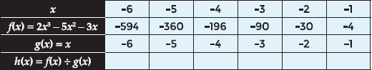

3. Find the quotient w(x) of the quadratic function u(x) = 6x2 + 7x – 3 divided by the linear function v(x) = 2x + 3 symbolically and verify the equation graphically.



Algebraic Reasoning

Name:______________________

Per:_____

POINTS:____

Classwork #32 Quiz

**Be sure to include your work when appropriate.**

1. Complete the table for missing h(x) values.



2. Use the table for the function

f(x) = 2x3 – 5x2 – 3x and g(x) = x to find the values for the quotient h(x) = f(x) ÷ g(x). Then use finite differences to write the function rule for h(x).



3. Find the quotient w(x) of the quadratic function u(x) = 6x2 + 7x – 3 divided by the linear function v(x) = 2x + 3 symbolically and verify the equation graphically.



**For questions 4 – 8, determine the quotient h(x) = f(x) ÷ g(x) for the given functions f(x) and g(x).**

**4.** Find h(x) = f(x) ÷ g(x) for f(x) = 3x2 + 17x + 10 and g(x) = x + 5.

**5.** Find h(x) = f(x) ÷ g(x) for f(x) = 2x – 5 and

g(x) = 2x2 + 7x – 30.

**6.** Find h(x) = f(x) ÷ g(x) for f(x) = 4x3 – 17x2 + 15x and g(x) = 4x2 – 5x.

**7.** Find h(x) = f(x) ÷ g(x) for f(x) = 6x and g(x) = 8x2 – 2x.

**8.** Find h(x) = f(x) ÷ g(x) for f(x) = 6x3 – 21x2 – 45x and g(x) = 2x + 3.

**For questions 4 – 8, determine the quotient h(x) = f(x) ÷ g(x) for the given functions f(x) and g(x).**

**4.** Find h(x) = f(x) ÷ g(x) for f(x) = 3x2 + 17x + 10 and g(x) = x + 5.

**5.** Find h(x) = f(x) ÷ g(x) for f(x) = 2x – 5 and

g(x) = 2x2 + 7x – 30.

**6.** Find h(x) = f(x) ÷ g(x) for f(x) = 4x3 – 17x2 + 15x and g(x) = 4x2 – 5x.

**7.** Find h(x) = f(x) ÷ g(x) for f(x) = 6x and g(x) = 8x2 – 2x.

**8.** Find h(x) = f(x) ÷ g(x) for f(x) = 6x3 – 21x2 – 45x and g(x) = 2x + 3.