Algebraic Reasoning

Name:______________________

Per:_____

POINTS:____

Classwork #30 Quiz

**Be sure to include your work when appropriate.**

**Use the functions to answer the questions.**

**p(x) = 3(x + 1) – 6**

**q(x) = -2(x – 3) + 4**

**r(x) = p(x) + q(x)**

**s(x) = p(x) – q(x)**

1. Complete the table shown for specific x values for p(x), q(x), r(x), and s(x).



1. Sketch a graph of the functions p(x), q(x), r(x) and s(x).



1. Write the equation of the combined function

r(x) = p(x) + q(x).

1. Write the equation of the separated function s(x) = p(x) – q(x).

Algebraic Reasoning

Name:______________________

Per:_____

POINTS:____

Classwork #30 Quiz

**Be sure to include your work when appropriate.**

**Use the functions to answer the questions.**

**p(x) = 3(x + 1) – 6**

**q(x) = -2(x – 3) + 4**

**r(x) = p(x) + q(x)**

**s(x) = p(x) – q(x)**

1. Complete the table shown for specific x values for p(x), q(x), r(x), and s(x).



1. Sketch a graph of the functions p(x), q(x), r(x) and s(x).



1. Write the equation of the combined function

r(x) = p(x) + q(x).

1. Write the equation of the separated function s(x) = p(x) – q(x).

**Use the functions to answer the questions.**

**p(x) = 8(0.5x + 1)3 + 1**

**q(x) = -7(x – 3)**

**r(x) = p(x) + q(x)**

**s(x) = p(x) − q(x)**

1. Complete the table shown for specific x values for p(x), q(x), r(x), and s(x).

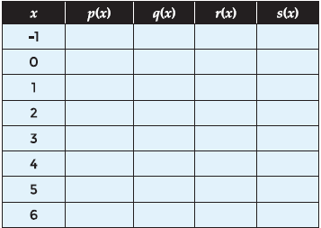

1. Sketch a graph of the functions p(x), q(x), r(x) and s(x).



1. Write the equation of the combined function r(x) = p(x) + q(x).
2. Write the equation of the separated function s(x) = p(x) – q(x).

**Use the functions to answer the questions.**

**p(x) = 8(0.5x + 1)3 + 1**

**q(x) = -7(x – 3)**

**r(x) = p(x) + q(x)**

**s(x) = p(x) − q(x)**

1. Complete the table shown for specific x values for p(x), q(x), r(x), and s(x).



1. Sketch a graph of the functions p(x), q(x), r(x) and s(x).



1. Write the equation of the combined function r(x) = p(x) + q(x).
2. Write the equation of the separated function s(x) = p(x) – q(x).