Algebraic Reasoning

Name:______________________

Per:_____

POINTS:____

Classwork #29 Quiz

**Be sure to include your work when appropriate.**

1. **Use a table to write a function rule for h(x).**

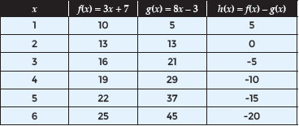

2. **Use a table to write a function rule for h(x).** 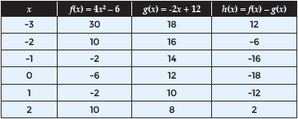

Algebraic Reasoning

Name:______________________

Per:_____

POINTS:____

Classwork #29 Quiz

**Be sure to include your work when appropriate.**

1. **Use a table to write a function rule for h(x).**



2. **Use a table to write a function rule for h(x).** 

**Write the simplified form of h(x) if h(x) = f(x) – g(x).**

**3.** f(x) = 0.5x + 15

g(x) = -3x – 5

**4.** f(x) = x3 – 2x

g(x) = x2 + 5

**5.** f(x) = 5x – 3

g(x) = 0.5x2 – 4

**Write the simplified form of h(x) if h(x) = f(x) – g(x).**

**3.** f(x) = 0.5x + 15

g(x) = -3x – 5

**4.** f(x) = x3 – 2x

g(x) = x2 + 5

**5.** f(x) = 5x – 3

g(x) = 0.5x2 – 4