**Study Guide and Intervention**

***Generating Inverses of Functions***

 **Generate the inverse of the exponential function represented in the table that follows. Is the inverse a function? Justify your answer.**

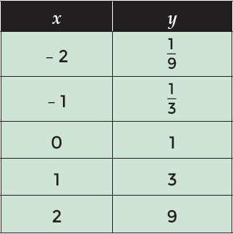

**Solution**

**Step 1** Determine the inverse by switching the domain and range values of the original function.

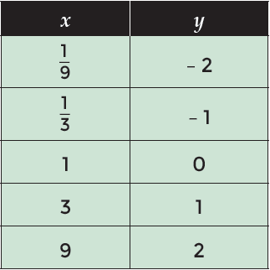

**Step 2** Evaluate the domain and range of the inverse to determine whether or not the inverse is a function.

Each domain value in the inverse’s table results in a single range value in the in-verse’s table. There-fore, it is reasonable to conclude that the inverse is also a function***.***

**Exercises**

**Generate the inverse of the function. Determine if the inverse is a function. Explain your answer.**

**1.**

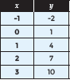

**3.**

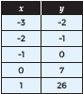

**2.**

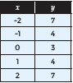

**4.**

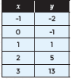

**Study Guide and Intervention**

***Generating Inverses of Functions (cont.)***

**Generate the graph of the inverse of the cubic function *f*(*x*) = – (*x* + 2)3 + 1 whose graph is shown below.**

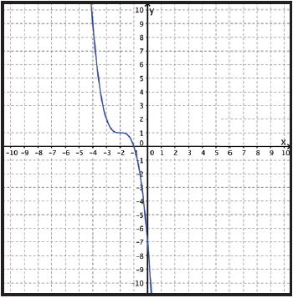

**Solution**

**Step 1** Determine several points on the original graph that represent the general shape of the curve as well as key attributes of the function, such as intercepts.

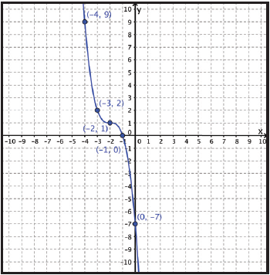

**Step 2** Switch the ***x***- and ***y***-values of each of the chosen points from the original graph and graph them on the coordinate plane. Then draw the curve of the inverse through the points you graphed on the coordinate plane.

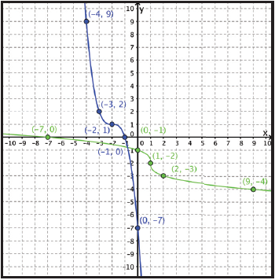

**Step 3** Verify visually that the graphs are reflections of one another across the line ***y*** = ***x*** and that the graphed points are the same distance from the line ***y*** = ***x***.

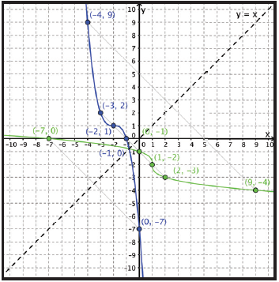

**Exercises**

**Generate the graph of the inverse of the function. Determine the *x*-intercept(s) and *y*-intercept(s) of the original function and the *x*-intercept(s) and *y*-intercept(s) of the inverse of the function.**

**5. 6.**  f(x) = 4($\frac{\text{-}\text{1}}{\text{8}}$ x + 2) – 5 **7.** f(x) = $\frac{\text{1}}{\text{4}}$ (x + 8)



**8.** f(x) = -2($\frac{\text{-}\text{1}}{\text{2}}$ x + 3) + 5 **9.** f(x) = $\frac{\text{-}\text{2}}{\text{5}}$ (x + 8) **10.** f(x) = -3(2x + 5) + 9