**Study Guide and Intervention**

***Cube Root Functions***

 **Using graphs and tables, verify whether or not *f*(*x*) = *x*3 – 3 and *g*(*x*) = $\sqrt[3]{x}-2$ are inverses, including checking any domain restrictions.**

**Solution**

**Step 1 Graph f(x) and g(x) on the same coordinate plane. Use the line of reflection y = x to determine whether the functions could be inverses.**

.

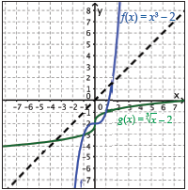

The graphs do not appear to be reflections of one another over the line *y* = *x*.

**Step 2** Examine the tables side by side to determine whether the functions could be inverses.

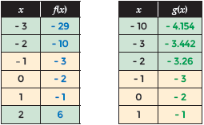

Although f(x) = x3 – 3 and g(x) = $\sqrt[3]{x}-2$ have similar parameters, they are not inverse functions.

**Exercises**

**Generate the inverse of each cubic function.**

**1.** *y* = 2(3*x* + 4)3 – 1

**3.** *y* = (2*x* + 1)3 + 3

**2.** *y* = (*x* – 4)3 + 8

**4.** *y* = –(6*x* + 4)3 + 1

**Determine if each pair of equations, tables, or graphs represent a cubic function and its inverse.**

**5.** *f*(*x*) = *x*3 + 1 and g(x) = – 1

**7.**

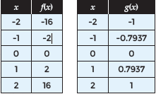

**6.** f(x) = x3 + 4 and g(x) = $\sqrt[3]{x-4}$

**8.**

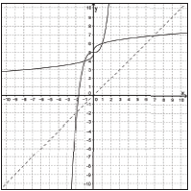

**Study Guide and Intervention**

***Cube Root Functions (cont.)***

 **Compare the domain and range as well as any intercepts, if they exist, of the functions graphed below. Write domain and range as inequalities, intervals, or in set builder notation.**

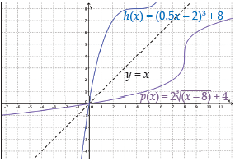

**Solution**

**Step 1 Determine the domain and range of the cubic function h(x).**

Since *h*(*x*) is a cubic function, its domain and range contains all real numbers.

**Step 2 Determine the domain and range of the cube root function *p* (*x*).**

Since *p*(*x*) is a cube root function, its domain and range contains all real numbers.

**Step 3** Compare the domains and ranges of the two functions.

The range of *h*(*x*) is the same as the domain of *p*(*x*). And the domain of *h*(*x*) is the same as the range of *p*(*x*).

**Step 4 Determine the x- and *y*-intercepts of *h*(*x*) and *p*(*x*).**

Examining the graph, both the *x*- and *y*-intercepts of *h*(*x*) and *p*(*x*) are (0, 0).

**Step 5** **Compare the intercepts of the two functions.**

These functions are inverses of one another. Their domain and range both contain all real numbers, their *x*- and *y*-intercepts are at the origin, which is their point of intersection.

**Exercises**

**Compare the domain and range as well as any intercepts, if they exist, of the functions graphed below. Write domain and range as inequalities, intervals, or in set builder notation.**

**9.** f(x) = (x + 1)3  **10.** f(x) = 2(x + 2)3 – 2

g(x) = - 1 g(x) =

