**Study Guide and Intervention**

***Verifying Inverses of Functions***

 **Determine whether or not the tables represent functions that are inverses. Justify your answer.**

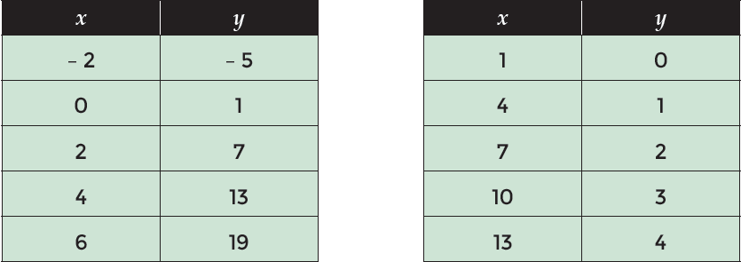

**Solution**

**Step 1** Compare the domain of one table with the range of the other and vice versa.

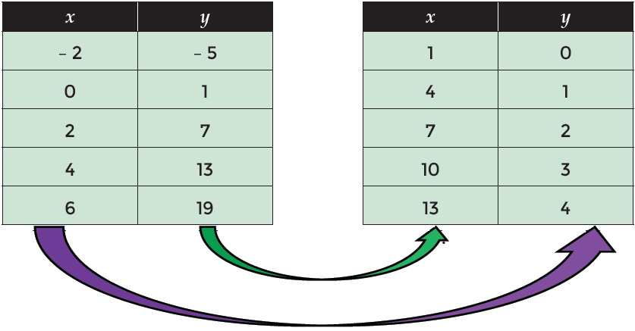

**Step 2** Evaluate the similar portions of the domain and range of the left hand table and the range and domain of the right hand table.

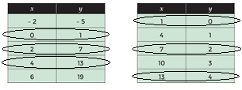

**Exercises**

**Indicate if the data in each pair of tables represent inverse functions or not.**

**1.**

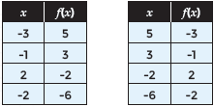

**3.**

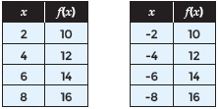

**2.**

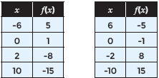

**4.**

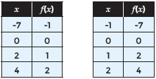

**Study Guide and Intervention**

***Verifying Inverses of Functions (cont.)***

 **Each graph shows a function and its inverse. Determine how the domain of f(x) should be restricted so the inverse is also a function.**

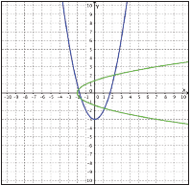

**Step 1** Draw perpendicular lines on one of the graphs to see where the line stops intersecting the graph in two places.

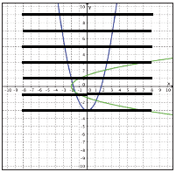

**Step 2** The last line should pass through the vertex. The vertex will help determine the domain restrictions to insure that the inverse will be a function.

The vertex is at (0,-3).

Therefore, the domain restrictions will occur at -3.

x ≥ -3 or x ≤ -3

**Exercises**

**Each graph shows a function and its inverse. Determine how the domain of f(x) should be restricted so the inverse is also a function.**

**5.** **6.**

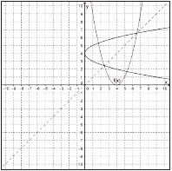 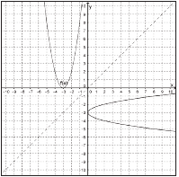

**Study Guide and Intervention**

***Verifying Inverses of Functions (cont.)***

**7. 8.**

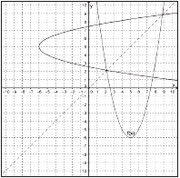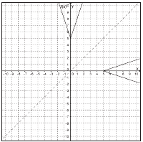

**Indicate if each graph represents an inverse relationship or not. Justify your answer.**

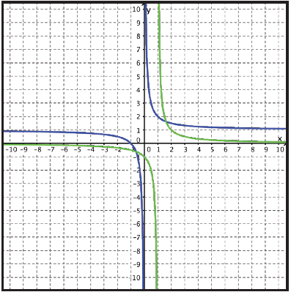

**Step 1** Graph the line ***y*** = ***x*** on the coordinate plane. Choose ordered pairs that appear to be (***x***, ***y***) and (***y***, ***x***). Draw line segments to connect the related points.

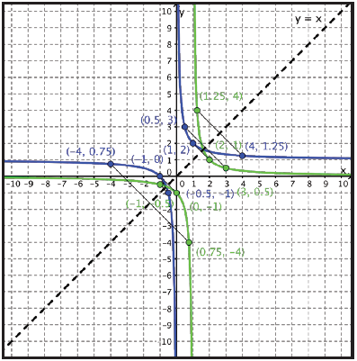

**Step 2** Evaluate whether the line ***y*** = ***x*** is a line of symmetry between the two graphs.

The graphs appear to be inverses because they are reflections of one another over the line y = x.

**Study Guide and Intervention**

***Verifying Inverses of Functions (cont.)***

**Exercises**

**Indicate if each graph represents an inverse relationship or not.**

**9. 10.**

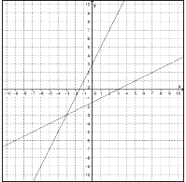 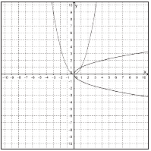

**11. 12.**

