Algebraic Reasoning

Name:______________________

Per:_____

POINTS:____

Classwork #26 Quiz

**Be sure to include your work when appropriate.**

**Generate the inverse of each cubic function.**

1. y = (2x + 1)3 + 3

2. y = – (6x + 4)3 + 1

3. **Determine if the pair of equations, tables, or graphs represent a cubic function and its inverse.**

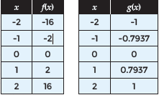

Algebraic Reasoning

Name:______________________

Per:_____

POINTS:____

Classwork #26 Quiz

**Be sure to include your work when appropriate.**

**Generate the inverse of each cubic function.**

1. y = (2x + 1)3 + 3

2. y = – (6x + 4)3 + 1

3. **Determine if the pair of equations, tables, or graphs represent a cubic function and its inverse.**



**Compare the domain and range as well as any intercepts, if they exist, of the functions graphed below. Write domain and range as inequalities, intervals, or in set builder notation.**

4. Use the graph of g(x) = x – 1 and

f(x) = (x + 1)3

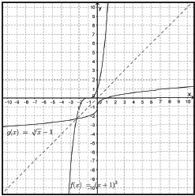

5. use the graph of g(x) = and

f(x) = -x3 - 8

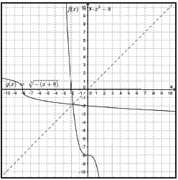

**Compare the domain and range as well as any intercepts, if they exist, of the functions graphed below. Write domain and range as inequalities, intervals, or in set builder notation.**

4. Use the graph of g(x) = x – 1 and

f(x) = (x + 1)3



5. use the graph of g(x) = and

f(x) = -x3 - 8

