Algebraic Reasoning

Name:______________________

Per:_____

POINTS:____

Classwork #25 Quiz

**Be sure to include your work when appropriate.**

**Identify the endpoint of each function**

1. f(x) =

2. f(x) = -+ 3

3. Using graphs and tables, verify whether or not *f*(*x*) = *x*2 + 2 and *g*(*x*) = $\sqrt{x-2}$ are inverses, if the domain of *f*(*x*) is restricted to {*x* | *x* ≥ 0}, including checking the domain restrictions.

Algebraic Reasoning

Name:______________________

Per:_____

POINTS:____

Classwork #25 Quiz

**Be sure to include your work when appropriate.**

**Identify the endpoint of each function**

1. f(x) =

2. f(x) = -+ 3

3. Using graphs and tables, verify whether or not *f*(*x*) = *x*2 + 2 and *g*(*x*) = $\sqrt{x-2}$ are inverses, if the domain of *f*(*x*) is restricted to {*x* | *x* ≥ 0}, including checking the domain restrictions.

**Compare the domain and range as well as any intercepts, if they exist, of the functions graphed below. Write domain and range as inequalities, intervals, or in set builder notation.**

4.

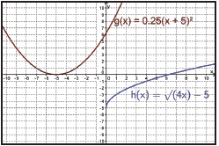

5.

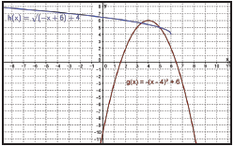

**Compare the domain and range as well as any intercepts, if they exist, of the functions graphed below. Write domain and range as inequalities, intervals, or in set builder notation.**

4.



5.

