Algebraic Reasoning

Name:______________________

Per:_____

POINTS:____

Classwork #24 Quiz

**Be sure to include your work when appropriate.**

**Indicate if the data in each pair of tables represent inverse functions or not.**

1.

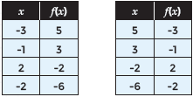

2.

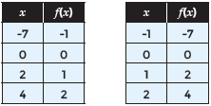

Algebraic Reasoning

Name:______________________

Per:_____

POINTS:____

Classwork #24 Quiz

**Be sure to include your work when appropriate.**

**Indicate if the data in each pair of tables represent inverse functions or not.**

1.



2.



**Each graph shows a function and its inverse. Determine how the domain of f(x) should be restricted so the inverse is also a function.**

3.

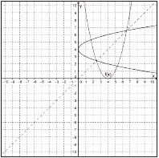

**Indicate if each graph represents an inverse relationship or not.**

4.

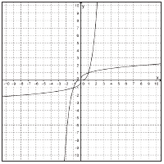

5.

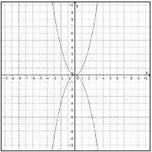

**Each graph shows a function and its inverse. Determine how the domain of f(x) should be restricted so the inverse is also a function.**

3.



**Indicate if each graph represents an inverse relationship or not.**

4.



5.

