**Writing Linear Functions**

**Determine whether or not the relationship shows a linear function. If the data set represents a linear function, write the equation for the function.**

5.

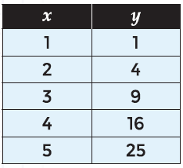

*SOLUTION*:

Δx = 1; Δy = 3, 5, 7, 9

nonlinear because Δy is not constant

*ANSWER*:

nonlinear

6.

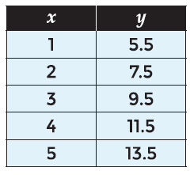

*SOLUTION*:

Δx = 1; Δy = 2

Linear because Δy is constant

m = $\frac{Δy}{Δx}$ = $\frac{2}{1}$ = 2

when x = 0, y = 5.5 – 2 = 3.5

y = 2x + 3.5

*ANSWER*:

y = 2x + 3.5

7.

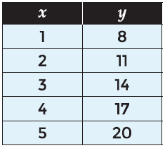

*SOLUTION*:

Δx = 1; Δy = 3

Linear because Δy is constant

m = $\frac{Δy}{Δx}$ = $\frac{3}{1}$ = 3

when x = 0, y = 8 – 3 = 5

y = 3x + 5

*ANSWER*:

y = 3x + 5

8.

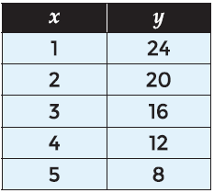

*SOLUTION*:

Δx = 1; Δy = -4

Linear because Δy is constant

m = $\frac{Δy}{Δx}$ = $\frac{-4}{1}$ = -4

when x = 0, y = 24 + 4 = 28

y = -4x + 28

*ANSWER*:

y = -4x + 28

9.

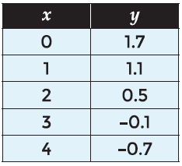

*SOLUTION*:

Δx = 1; Δy = -0.6

Linear because Δy is constant

m = $\frac{Δy}{Δx}$ = $\frac{-0.6}{1}$ = -0.6

when x = 0, y = 1.7

y = -0.6x + 1.7

*ANSWER*:

y = -0.6x + 1.7

10.

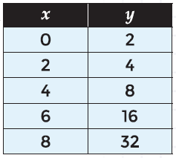

*SOLUTION*:

Δx = 2; Δy = 2, 4, 8, 16

nonlinear because Δy is not constant

*ANSWER*:

nonlinear

11.

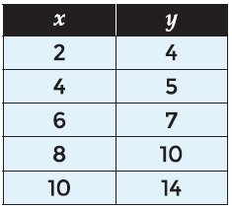

*SOLUTION*:

Δx = 2; Δy = 1, 2, 3, 4

nonlinear because Δy is not constant

*ANSWER*:

nonlinear

12.

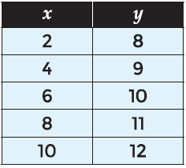

*SOLUTION*:

Δx = 2; Δy = 1

Linear because Δy is constant

m = $\frac{Δy}{Δx}$ = $\frac{1}{2}$ = 0.5

when x = 0, y = 8 – 1 = 7

y = 0.5x + 7

*ANSWER*:

y = 0.5x + 7

13.

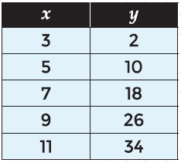

*SOLUTION*:

Δx = 2; Δy = 8

Linear because Δy is constant

m = $\frac{Δy}{Δx}$ = $\frac{8}{2}$ = 4

when x = 0, y = 2 – 12 = -10

y = 4x - 10

*ANSWER*:

y = 4x - 10

14.

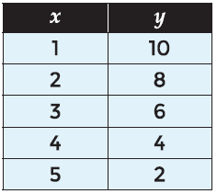

*SOLUTION*:

Δx = 1; Δy = -2

Linear because Δy is constant

m = $\frac{Δy}{Δx}$ = $\frac{-2}{1}$ = -2

when x = 0, y = 10 + 2 = 12

y = -2x + 12

*ANSWER*:

y = -2x + 12

15.

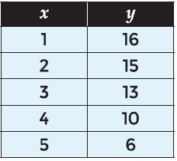

*SOLUTION*:

Δx = 1; Δy = -1, -2, -3

nonlinear because Δy is not constant

*ANSWER*:

nonlinear

16.

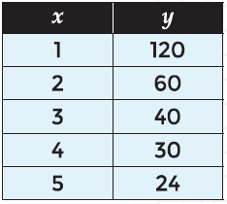

*SOLUTION*:

Δx = 1; Δy = -60, -20, -10, -6

nonlinear because Δy is not constant

*ANSWER*:

nonlinear