Algebraic Reasoning

Name:______________________

Per:_____

POINTS:____

Homework #15 Quiz

**Be sure to include your work when appropriate.**

1. **determine whether the set of data represents a linear, exponential, quadratic, or cubic function.**

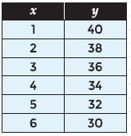

2. **determine if the given relationship is a cubic function. If it is, write a function relating the variables.**

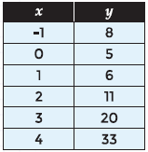

Algebraic Reasoning

Name:______________________

Per:_____

POINTS:____

Homework #15 Quiz

**Be sure to include your work when appropriate.**

1. **determine whether the set of data represents a linear, exponential, quadratic, or cubic function.**



2. **determine if the given relationship is a cubic function. If it is, write a function relating the variables.**



3. Write a cubic function for the values in the table.

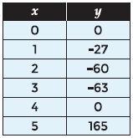

A local mail service charges different rates, based on the weight of the packages mailed. A sample of their prices is shown in the table below.

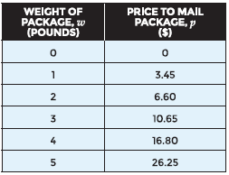

4. Use a cubic function to determine the cost to mail a 6-pound package.

3. Write a cubic function for the values in the table.



A local mail service charges different rates, based on the weight of the packages mailed. A sample of their prices is shown in the table below.



4. Use a cubic function to determine the cost to mail a 6-pound package.