**Modeling Quadratic Functions**

**For questions 1-6, determine whether the set of data represents a linear, quadratic or exponential function.**

2.

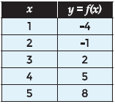

*SOLUTION*:

Δy = -1 – (-4) = 3

Δy = 2 – (-1) = 3

Δy = 5 – 2 = 3

Δy = 8 – 5 = 3

The first finite differences are all 3, so the data represents a linear function

*ANSWER*:

Linear function

4.

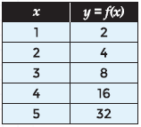

*SOLUTION*:

Δy = 4 – 2 = 2 Δ2y = 4 – 2 = 2 = = 2

Δy = 8 – 4 = 4 Δ2y = 8 – 4 = 4 = = 2

Δy = 16 – 8 = 8 Δ2y = 16 – 8 = 8 = = 2

Δy = 32 – 16 = 16 $\frac{yn-1}{y}$ = $\frac{32}{16}$ = 2

The ratios are all 2, so the data represents an exponential function

*ANSWER*:

Exponential function

6.

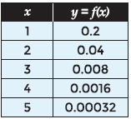

*SOLUTION*:

Δy = -.16 Δ2y = .128 = 0.2

Δy = -.032 Δ2y = .0256 = 0.2

Δy = -.0064 Δ2y = .00512 $\frac{yn-1}{y}$ = 0.2

Δy = -.00128 $\frac{yn-1}{y}$ = 0.2

The ratios are all 0.2, so the data represents an exponential function

*ANSWER*:

Exponential function

**For questions 7-12 use the data set to generate a quadratic function that best models the data.**

8.

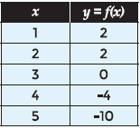

*SOLUTION*:

Δy = 0 Δ2y = -2

Δy = -2 Δ2y = -2

Δy = -4 Δ2y = -2

Δy = -6

Δ2y = -2; 2a = -2; a = -1

when x = 0, Δy = 2; a + b = 2; b = 3

y-int = c = 0

*ANSWER*:

y = -x2 + 3x

10.

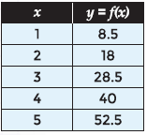

*SOLUTION*:

Δy = 9.5 Δ2y = 1

Δy = 10.5 Δ2y = 1

Δy = 11.5 Δ2y = 1

Δy = 12.5

Δ2y = 1; 2a = 1; a = ½

when x = 0, Δy = 8.5; a + b = 8.5; b = 8

y-int = c = 0

*ANSWER*:

y = ½x2 + 8x

12.

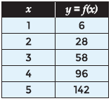

*SOLUTION*:

Δy = 22 Δ2y = 8

Δy = 30 Δ2y = 8

Δy = 38 Δ2y = 8

Δy = 46

Δ2y = 8; 2a = 8; a = 4

when x = 0, Δy = 14; a + b = 14; b = 10

y-int = c = -8

*ANSWER*:

y = 4x2 + 14x - 8

**For questions 13-14, use the following information.**

The Texas Department of Public Safety can use the length of skid marks to help determine the speed of a vehicle before the brakes were applied. The quadratic function that best models the data is f(x) =  where x represents the speed of the vehicle and f(x) is the length of the skid mark. The speeds of a vehicle and the length of the corresponding skid marks are shown in the table below.

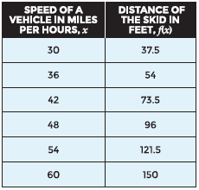

14. Use the table of data to determine how fast a vehicle was traveling if the length of the skid mark was 24 feet.

*SOLUTION*:

Graph the equation, then use the calculator to see the complete table. Look at the y-values for 24, then give the corresponding x-value.

*ANSWER*:

24 miles per hour

**For questions 15 – 17, use the following information.**

A ball is thrown upward with an initial velocity of 35 meters per second. The position of the ball over time is recorded in the table below.

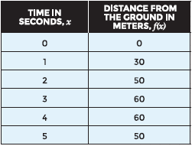

16. Use the data in the table to find the height of the ball after 7 seconds.

*SOLUTION*:

Graph the equation, then use the calculator to see the complete table. Look at the x-values for 7, then give the corresponding y-value.

*ANSWER*:

0 feet

**For questions 18-20, use the following information.**

Judy wants to construct a rectangular pen for her puppy, but only has 56 feet of fencing to use for the pen. The table below shows the width, length, and area of different size pens.

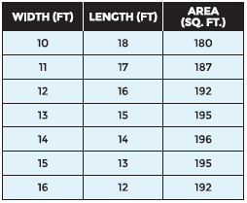

18. Use the data in the table to generate a quadratic function that models the data.

*SOLUTION*:

Δy = 7 Δ2y = -2

Δy = 5 Δ2y = -2

Δy = 3 Δ2y = -2

Δy = 1 Δ2y = -2

Δy = -1 Δ2y = -2

Δy = -3

The calculator yields the equation y = -x2 + 28x

*ANSWER*:

y = -x2 + 28x

20. Use the data in the table to determine the area of the pen where one of the dimensions measures 20 feet.

*SOLUTION*:

Make a table of the function, y = -x2 + 28x, and look at where the x-value is 20.

*ANSWER*:

160 ft2