Algebraic Reasoning

Name:______________________

Per:_____

POINTS:____

Homework #11 Quiz

**Be sure to include your work when appropriate.**

**Use finite differences to determine if each**

**table represents an exponenetial function.**

1.

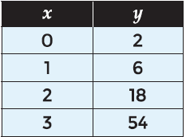

**Identify if each table represents an exponential function or not. If the table represents an exponential function, identify**

**the common ratio.**

2.

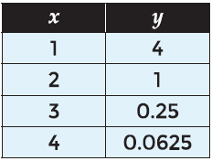

Algebraic Reasoning

Name:______________________

Per:_____

POINTS:____

Homework #11 Quiz

**Be sure to include your work when appropriate.**

**Use finite differences to determine if each**

**table represents an exponenetial function.**

1.



**Identify if each table represents an exponential function or not. If the table represents an exponential function, identify**

**the common ratio.**

2.



**Identify if each table represents an exponential function or not. If the table represents an exponential function, write the function relating the variables.**

3.

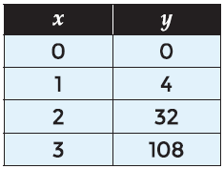

4.

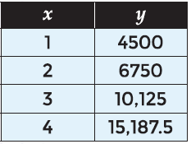

**Identify if each table represents an exponential function or not. If the table represents an exponential function, write the function relating the variables.**

3.



4.

