**Writing Exponential Functions**

**For questions 1-4 use finite differences to determine if each table represents an exponential function.**

1.

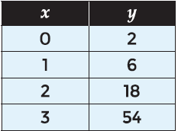

*SOLUTION*:

Δx = 1; $\frac{yn }{yn-1}$ = $\frac{6 }{2}$ = $\frac{18}{6}$ = $\frac{54}{18}$ = 3

Values are constant; exponential

*ANSWER*:

yes

2.

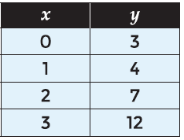

*SOLUTION*:

Δx = 1; $\frac{yn }{yn-1}$ ≠ $\frac{4 }{3}$ ≠ $\frac{7}{4}$ ≠ $\frac{12}{7}$

Values are not constant; not exponential

*ANSWER*:

no

3.

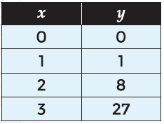

*SOLUTION*:

Δx = 1; $\frac{yn }{yn-1}$ ≠ $\frac{1}{0}$ ≠ $\frac{8}{1}$ ≠ $\frac{27}{8}$

Values are not constant; not exponential

*ANSWER*:

No

4.

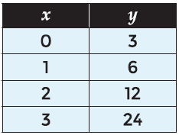

*SOLUTION*:

Δx = 1; $\frac{yn }{yn-1}$ = $\frac{6 }{3}$ = $\frac{12}{6}$ = $\frac{24}{12}$ = 2

Values are constant; exponential

*ANSWER*:

yes

**For questions 5-8 identify if each table represents an exponential function or not. If the table represents an exponential function, identify the common ratio.**

5.

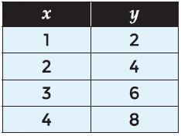

*SOLUTION*:

Δx = 1; $\frac{yn }{yn-1}$ ≠ $\frac{4 }{2}$ ≠ $\frac{6}{4}$ ≠ $\frac{8}{6}$

Not exponential

*ANSWER*:

No; none

6.

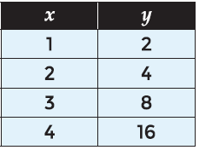

*SOLUTION*:

Δx = 1; $\frac{yn }{yn-1}$ = $\frac{4}{2}$ = $\frac{8}{4}$ = $\frac{16}{8}$ = 2

Constant; exponential

*ANSWER*:

Exponential Function: Yes

Common Ratio: 2

7.

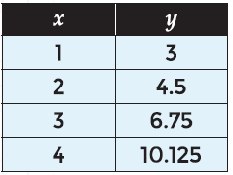

*SOLUTION*:

Δx = 1; $\frac{yn }{yn-1}$ = $\frac{4.5}{3}$ = $\frac{6.75}{4.5}$ = $\frac{10.125}{6.75}$ = 1.5

Constant; exponential

*ANSWER*:

Exponential Function: Yes

Common Ratio: 1.5

8.

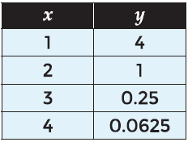

*SOLUTION*:

Δx = 1; $\frac{yn }{yn-1}$ = $\frac{1}{4}$ = $\frac{0.25}{1}$ = $\frac{0.0625}{0.25}$ = 0.25

Constant; exponential

*ANSWER*:

Exponential Function: Yes

Common Ratio: 0.25

**For questions 9-12 use the situation below.**

**A sheet of paper is 0.1 mm thick. When the paper is folded in half, the total thickness of the layers of paper is 0.2 mm. When the paper is folded in half again, the total thickness of the layers of paper is 0.4 mm.**

9. Complete the table below to represent the situation.

S*OLUTION*:

* 1. * 2 = 0.2
  2. * 2 = 0.4
  3. * 2 = 0.8
  4. * 2 = 1.6

*ANSWER*:

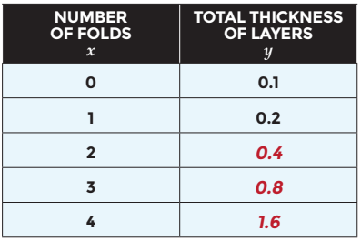

10. Does the situation represent a linear function or an exponential function? Justify your answer.

*ANSWER*:

Exponential; Δx is constant, Δy is not constant, and $\frac{yn }{yn-1}$ is constant

11. Which of the following represents the function that models this situation?

A. y = x + 0.1 C. y = 0.1 * 2x

B. y = 2 * 0.1x D. y = 2x + 0.1

*ANSWER*:

C. y = 0.1 * 2x

12. Which of the following statements are true about the situation?

*ANSWER*: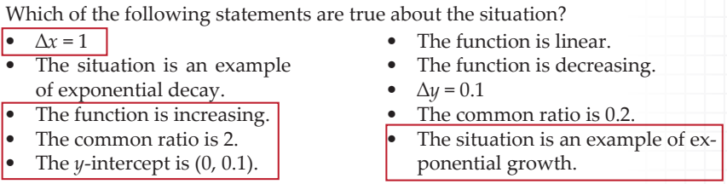

**For questions 13-18 identify if each table represents an exponential function or not. If the table represents an exponential function, write the function relating the variables.**

13.

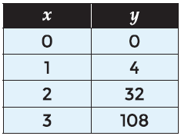

*SOLUTION*:

Δx = 1; $\frac{yn }{yn-1}$ ≠ $\frac{4 }{0}$ ≠ $\frac{32}{4}$ ≠ $\frac{108}{32}$

Not constant; not exponential

*ANSWER*:

Exponential Function: No

Function: none

**14.**

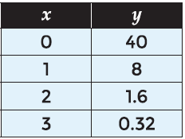

*SOLUTION*:

Δx = 1; $\frac{yn }{yn-1}$ = $\frac{8}{40}$ = $\frac{1.6}{8}$ = $\frac{0.32}{1.6}$ = 0.2

Constant; Exponential

*ANSWER*:

Exponential Function: Yes

Function: y = 40 * 0.2x

15.

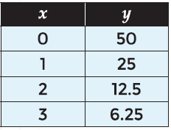

*SOLUTION*:

Δx = 1; $\frac{yn }{yn-1}$ = $\frac{25}{50}$ = $\frac{12.5}{25}$ = $\frac{6.25}{12.5}$ = 0.5

Constant; Exponential

*ANSWER*:

Exponential Function: Yes

Function: y = 50 * 0.5x

16.

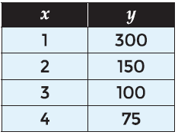

*SOLUTION*:

Δx = 1; $\frac{yn }{yn-1}$ ≠ $\frac{150 }{300}$ ≠ $\frac{100}{150}$ ≠ $\frac{75}{100}$

Not constant; not exponential

*ANSWER*:

Exponential Function: No

Function: none

17.

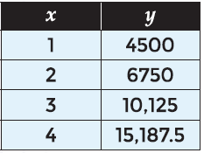

*SOLUTION*:

Δx = 1; $\frac{yn }{yn-1}$ = $\frac{6750}{4500}$ = $\frac{10125}{6750}$ = $\frac{15187.5}{10125}$ = 1.5

Constant; Exponential

x = 0, $\frac{4500}{a}$ = 1.5; $\frac{4500}{1.5}$ = 3000 = a

*ANSWER*:

Exponential Function: Yes

Function: y = 3000 * 1.5x

18.

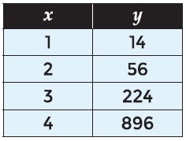

*SOLUTION*:

Δx = 1; $\frac{yn }{yn-1}$ = $\frac{56}{14}$ = $\frac{224}{56}$ = $\frac{896}{224}$ = 4

Constant; Exponential

x = 0, $\frac{14}{a}$ = 4; $\frac{14}{4}$ = 3.5 = a

*ANSWER*:

Exponential Function: Yes

Function: y = 3.5 * 4x

**For questions 19-20 use the situation below.**

A sheet of paper has an area of 100 square inches. When the paper is cut in half, the area of one piece is 50 square inches. When that piece is cut in half, the area of one piece is 25 square inches.

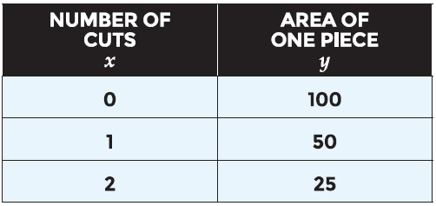

19. What would be the area of one piece after 5 cuts?

*SOLUTION*:

$\frac{yn }{yn-1}$ = $\frac{50}{100}$ = $\frac{25}{50}$ = .5;

25 * .5 = 12.5

12.5 * .5 = 6.25

6.25 * .5 = 3.125

*ANSWER*:

3.125 square inches

20. Write the function relating the variables.

*ANSWER*:

y = 100 * 0.5x