**Modeling with Linear Functions**

**For the following sets of data, calculate the average finite difference, and use that to determine the slope of a linear function that could model the data.**

1.

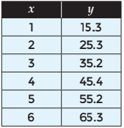

*SOLUTION*:

Δx = 1; Δy = +10, +9.9, +10.2, +9.8, +10.1

Avg Δy = $\frac{10 + 9.9 + 10.2 + 9.8 + 10.1}{5}$ = 10

$\frac{Δy}{Δx}$ = $\frac{10}{1}$ = 10

*ANSWER*:

10

2.



*SOLUTION*:

Δx = 1; Δy = -2.8, -2.9, -2.8, -3, -2.9, -3.1

Avg Δy = $\frac{-2.8 - 2.9 - 2.8 - 3 - 2.9 - 3.1}{6}$ = -2.9

$\frac{Δy}{Δx}$ = $\frac{2.9}{1}$ = -2.9

*ANSWER*:

-2.9

3.



*SOLUTION*:

Δx = 1; Δy = -0.2, +1.3, +0.65, +0.55

Avg Δy = $\frac{-0.2 + 1.3 + 0.65 + 0.55}{4}$ = .575

$\frac{Δy}{Δx}$ = $\frac{.575}{1}$ = .575

*ANSWER*:

.575

**For problems 4 – 6, determine a linear function to model the situation.**

4. Madeleine has a gift card to her favorite coffee shop. The table below shows how much is remaining on the gift card after each purchase at the coffee shop.

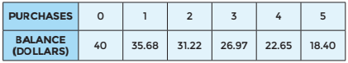

*SOLUTION*:

Δx = 1; Δy = -4.32, -4.46, -4.25, -4.32, -4.25

Avg Δy = $\frac{-4.32 - 4.46 - 4.25 - 4.32 - 4.25}{5}$ = -4.32

m = $\frac{Δy}{Δx}$ = $\frac{-4.32}{1}$ = -4.32

b = 40

y = -4.32x + 40

*ANSWER*:

y = -4.32x + 40

5. Gus records the mileage on his car so he can determine his average mileage per month. Below are some of his collected data.

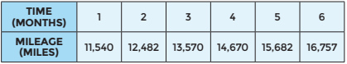

*SOLUTION*:

Δx = 1; Δy = +942, +1088, +1100, +1012, +1075

Avg Δy = $\frac{942 + 1088 + 1100 + 1012 + 1075}{5}$ = 1043.4

m = $\frac{Δy}{Δx}$ = $\frac{1043.4}{1}$ = 1043.4

b = 11,540 – 1043.4 = 10,496.6

y = 1043.4x + 10,496.6

*ANSWER*:

y = 1043.4x + 10,496.6

6. David is purchasing apps for his cell phone. The table below shows how his total cost changes with each app that he selects.

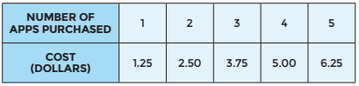

*SOLUTION*:

Δx = 1; Δy = +1.25, +1.25, +1.25, +1.25

Avg Δy = $\frac{1.25 + 1.25 + 1.25 + 1.25}{4}$ = 1.25

m = $\frac{Δy}{Δx}$ = $\frac{1.25}{1}$ = 1.25

b = 1.25 - 1.25 = 0

y = 1.25x + 0

*ANSWER*:

y = 1.25x

**Use the following situation to answer problems 7 – 10.**

Charlie is measuring his little brother’s height throughout the year to see how much he grows. The table below shows how his height changes during the first 5 months. 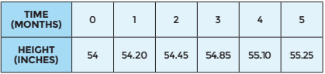

7. Write a function rule to model the situation.

*SOLUTION*:

Δx = 1; Δy = +0.20, +0.25, +0.40, +0.25, +0.15

Avg Δy = $\frac{0.20 + 0.25 + 0.40 + 0.25 + 0.15}{5}$ = 0.25

m = $\frac{Δy}{Δx}$ = $\frac{0.25}{1}$ = 0.25

b = 54

y = 0.25x + 54

*ANSWER*:

y = 0.25x + 54

8. What do the slope and y-intercept from your function rule mean in the context of this situation?

*ANSWER*:

The slope tells that he grows 0.25 in per month and the y-intercept tells us that he started at 54 in

9. Use your model to predict the height of Charlie’s brother after a year.

S*OLUTION*:

y = 0.25x + 54

y = 0.25(12) + 54

y = 3 + 54

y = 57 in

*ANSWER*:

y = 57 in

10. In what month will his height be approximately 56 inches?

*SOLUTION*:

y = 0.25x + 54

56 = 0.25x + 54

56 - 54 = 0.25x + 54 - 54

2 = 0.25x

$\frac{2}{0.25}$ = $\frac{0.25x}{0.25}$

8 = x

*ANSWER*:

x = 8; the 8th month

**Use the following situation to answer problems 11 – 13.**

Jeff noticed that the nutrition information on his box of cereal states that there are 14 servings in the cereal box. He decided to put their claim to the test. He recorded the weight of the remaining cereal after each serving, as shown in the table below.

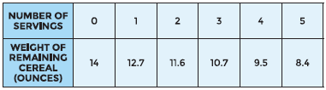

11. Write a function rule that models the situation.

*SOLUTION*:

Δx = 1; Δy = -1.3, -1.1, -0.9, -1.2, -1.1

Avg Δy = $\frac{-1.3 - 1.1 - 0.9 - 1.2 - 1.1}{5}$ = -1.12

m = $\frac{Δy}{Δx}$ = $\frac{-1.12}{1}$ = -1.12

b = 14

y = -1.12x + 14

*ANSWER*:

y = -1.12x + 14

12. What do the slope and y-intercept from your function rule mean in the context of this situation?

*ANSWER*:

The slope tells that he uses 1.12 ounces per serving and the y-intercept tells that he started with 14 ounces of cereal

13. Was Jeff able to confirm the claim on the cereal box by eating 14 servings? Explain your answer.

*SOLUTION*:

y = -1.12x + 14

0 = -1.12x + 14

0 – 14 = -1.12x + 14 – 14

-14 = -1.12x

$\frac{-14}{-1.12}$ = $\frac{-1.12x}{-1.12}$

12.5 = x

x = 12.5

*ANSWER*:

x = 12.5; he will finish in 12.5 servings, not 14. But we don’t know how many ounces he used. They only told us how many were left.

**Use the following situation to answer problems 14 – 17.**

Bob is tracking a hurricane moving toward the coast of Florida. The table shows its distance from land over time.

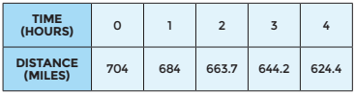

14. Write a function rule that models the situation.

*SOLUTION*:

Δx = 1; Δy = -20, -20.3, -19.5, -19.8

Avg Δy = $\frac{-20 - 20.3 - 19.5 - 19.8}{4}$ = -19.9

m = $\frac{Δy}{Δx}$ = $\frac{-19.9}{1}$ = -19.9

b = 704

y = -19.9x + 704

*ANSWER*:

y = -19.9x + 704

15. What do the slope and y-intercept from your function rule mean in the context of this situation?

*ANSWER*:

The slope tells that the hurricane is getting 19.9 miles closer to land every hour and the y-intercept tells that it started 704 miles away from land

16. About how far will the hurricane be from land after 24 hours?

*SOLUTION*:

y = -19.9x + 704

y = -19.9(24) + 704

y = -477.6 + 704

y = 226.4

*ANSWER*:

y = 226.4 miles

17. Approximately when will the hurricane make landfall?

*SOLUTION*:

y = -19.9x + 704

0 = -19.9x + 704

0 – 704 = -19.9x + 704 - 704

- 704 = -19.9x

$\frac{-704}{-19.9}$ = $\frac{-19.9x}{-19.9}$

35.38 = x

x = 35.38

*ANSWER*:

Shortly after 35 hours

**Use the following situation to answer problems 18 – 19.**

Maddie is running a 10-K (10 kilometer) race. She wears an electronic chip that tracks her progress throughout the race. She runs at a fairly steady pace throughout the race, as shown in her chip data below.

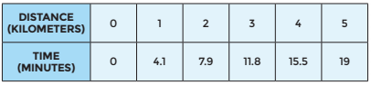

18. Write a function rule that models the situation.

*SOLUTION*:

Δx = 1; Δy = +3.8, +3.9, +3.7, +3.5

Avg Δy = $\frac{4.1+ 3.8 + 3.9 + 3.7+ 3.5}{5}$ = 3.8

m = $\frac{Δy}{Δx}$ = $\frac{3.8}{1}$ = 3.8

b = 0

y = 3.8x + 0

*ANSWER*:

y = 3.8x

19. If Maddie continues at this rate, will she beat her previous best time of 37.5 minutes? Explain your answer.

*SOLUTION*:

y = 3.8x

y = 3.8(10)

y = 38

*ANSWER*:

y = 38 minutes; no, she will not beat her previous time, she will be 0.5 minutes slower at this rate

**Use the following situation to answer problems 20 – 21.**

Nikki has a job as a waitress where she gets an hourly wage plus tips. The table below shows her total earnings for working one weekend.

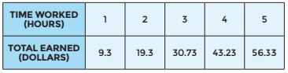

Nikki calculates that the function *f*(*x*) = 11.8x – 2.5 models her earnings over time. She understands that the slope of 11.8 means she earned an average of about $11.80 per hour. However, she is uncertain about why she has a negative y-intercept in her function equation, since she didn’t earn -$2.50 for working 0 hours.

20. Is her equation correct? Explain why or why not.

*SOLUTION*:

b = 9.3 – 11.8 = -2.5

*ANSWER*:

Yes, her equation is correct; it is not going to be exact, it is an approximation

21. Since she earned $0 for working zero hours, she now decides to include the point (0, 0) in her data set. How will this affect her function equation to model the situation?

*SOLUTION*:

Δx = 1; Δy = +9.3, +10, +11.43, +12.5, +13.1

Avg Δy = $\frac{9.3 + 10 + 11.43 + 12.5 + 13.1}{5}$ = 11.3

m = $\frac{Δy}{Δx}$ = $\frac{11.3}{1}$ = 11.3

b = 0

y = 11.3x + 0

*ANSWER*:

Her new equation looks like y = 11.3x; it’s close to the previous one, but now it goes through the point (0, 0).