**Graphing Linear Functions**

Graph the function represented by each table.

7.

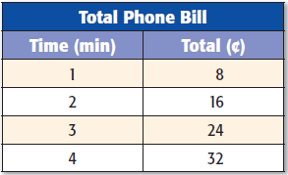

*ANSWER*:



8.

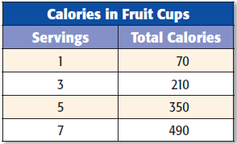

*ANSWER*:



9. y = x + 1

*ANSWER*:



10. y = x + 3

*ANSWER*:



11. y = x



12. y = -2x

*ANSWER*:



13y = 2x + 3

*ANSWER*:



14. y = 3x - 1

*ANSWER*:



17. y = 0.25x

*ANSWER*:



18. y = x + 0.5

*ANSWER*:



19. y = 0.5x - 1

*ANSWER*:

