Pre-AP Geometry

Name:______________________

Per:_____

POINTS:____

Homework #1 Quiz

**Be sure to include your work when appropriate.**

1. Identify the independent and dependent variables for the function.

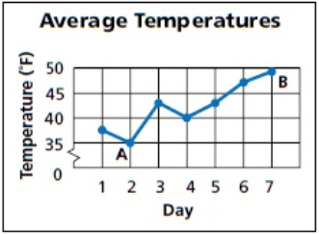

2. Identify the domain and range for this situation.

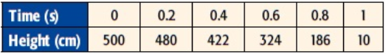

1. State whether the function is discrete or continuous. Explain.

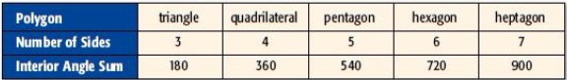

Pre-AP Geometry

Name:______________________

Per:_____

POINTS:____

Homework #1 Quiz

**Be sure to include your work when appropriate.**

1. 1. Identify the independent and dependent variables for the function.



2. Identify the domain and range for this situation.



1. State whether the function is discrete or continuous. Explain.

