**Domain and Range**

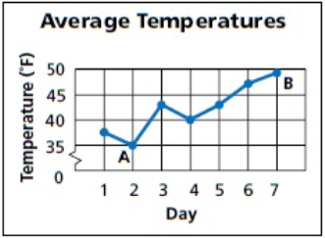

3. Identify the independent and dependent variables for the function.

*SOLUTION*:

Time (days) is independent of temperature. Therefore, Day is the independent variable and Temperature is the dependent variable.

*ANSWER*:

Independent Variable: Day

Dependent Variable: Temperature

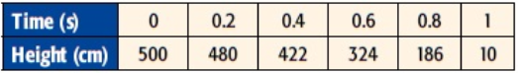

8. Identify the domain and range for this situation.

*SOLUTION*:

The domain is the set of independent variables. Time is independent of Height. Therefore the domain is {0, 0.2, .04, 0.6, 0.8, 1} This means that the range is {500, 480, 422, 324, 186, 10}

*ANSWER*:

Domain: {0, 0.2, .04, 0.6, 0.8, 1}

Range: {500, 480, 422, 324, 186, 10}

9. State whether the function is discrete or continuous. Explain.

*SOLUTION*:

Since Time is measured and not counted, this function is continuous.

*ANSWER*:

This is a continuous function because height is measured.

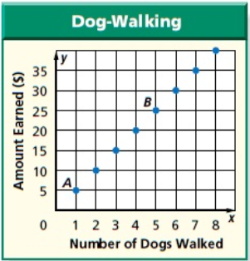

12. Identify the independent and dependent variables

for the function.

*SOLUTION*:

Since walking dogs is independent of making money, the number of dogs walked is the independent variable. This makes the amount earned the dependent variable.

*ANSWER*:

Independent Variable: Number of Dogs Walked

Dependent Variable: Amount Earned

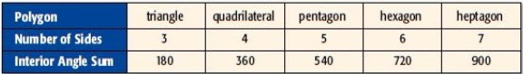

22. Identify the independent and dependent variables.

*SOLUTION*:

Since the number of sides refers to the shapes and not the sum of the angles, that makes the number of sides the independent variable, making the interior angle sum the dependent variable.

*ANSWER*:

Independent Variable: Number of Sides

Dependent Variable: Interior Angle Sum

23. Identify the domain and range for this situation.

*SOLUTION:*

Since the number of sides was previously identified as the independent variable, then the domain will be {3, 4, 5, 6, 7}. This makes the range {180, 360, 540, 720, 900}.

*ANSWER*:

Domain: {3, 4, 5, 6, 7}

Range: {180, 360, 540, 720, 900}

24. State whether the function is discrete or continuous. Explain.

*SOLUTION*:

Since the Number of Sides can be counted and not measured, this is a discrete function.

*ANSWER*:

Discrete