# Algebraic Reasoning Unit 3 Bundle 1 Summative Assessment Version A Answer Key

**Name: Date:**

Multiple Choice

1. If a given function *f*(*x*) has an inverse function *f –1*(*x*), which of the following statements is true?

**A** If (*a*, *b*) is on the graph of *f*(*x*), then the graph of *f –1*(*x*) must contain (–*b*, –*a*).

**B If *f*(*x*) has a *y*-intercept at (0, *c*), then the *x*-intercept of *f –1*(*x*) must be (*c*, 0).**

**C** Both *f*(*x*) and *f –1*(*x*) must have the same domain.

**D** Both *f*(*x*) and *f –1*(*x*) must have the same *y*-intercept.

1. The table below contains values of the function *f*(*x*).

|  |  |
| --- | --- |
| ***x*** | ***f*(*x*)** |
| 4 | –8 |
| 1 | –2 |
| 0 | 8 |
| –2 | 40 |

Which of the following tables represents *f* –1(*x*)?

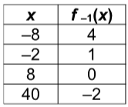

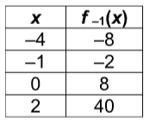

# H

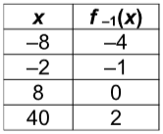

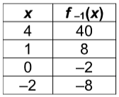

* 1. **J**

1. What type of function is the inverse of the function shown in the graph?

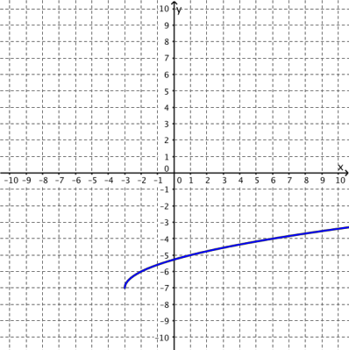

1. linear
2. quadratic
3. cubic
4. exponential
5. The graph of the function *f*(*x*) is shown. Which graph represents the inverse of *f*(*x*)?

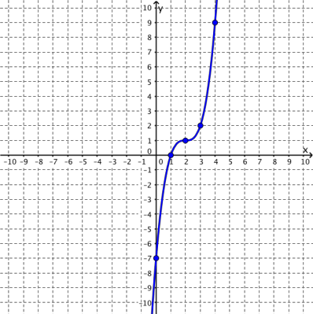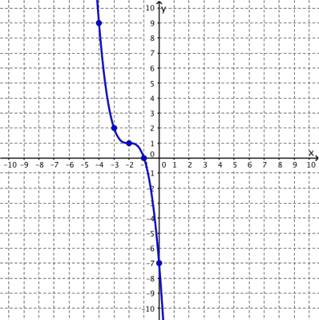

# H

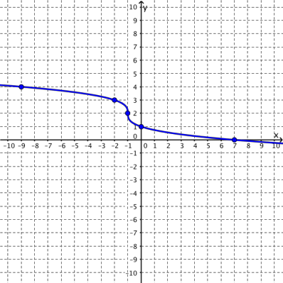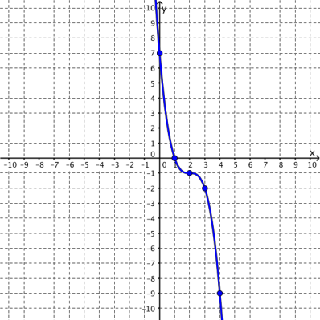

1. **J**

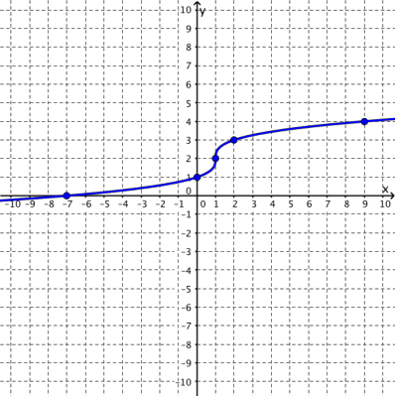

1. Which graph does **not** show inverse functions?

# C

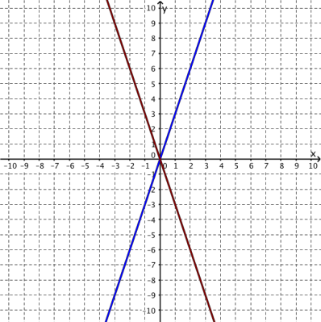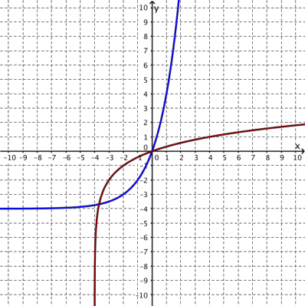

1. **D**

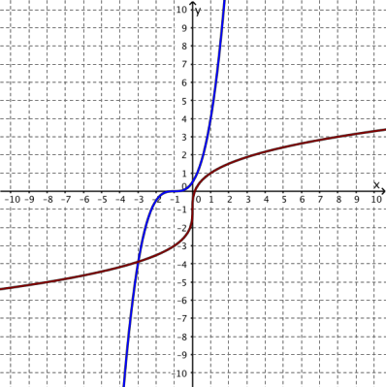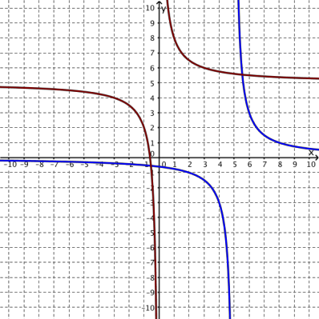

g(x) = $\frac{\sqrt{x-3+5}}{2}$

1. The graphs of the functions *f*(*x*) = (2*x* - 5)2 + 3 and

are shown below.

What must happen for the two functions to be inverses of each other?

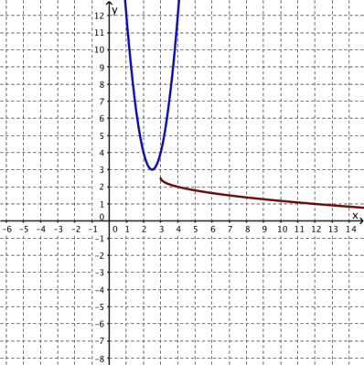

**F** The domain of *f*(*x*) must be restricted to {*x | x* ≥ 2.5}.

**G** The domain of *f*(*x*) must be restricted to {*x | x*  2.5}.

**H** The domain of *f*(*x*) must be restricted to {*x | x* ≥ 3}.

**J** The domain of *f*(*x*) must be restricted to {*x | x*  3}.

1. Given the function *f*(*x*) = (*x* + 2)3 – 27, what is the *y*-intercept of its inverse?

**A** (1, 0)

**B** (0, –19)

**C** (–19, 0)

**D** (0, 1)

1. A quadratic function has its vertex at (4, –4), *x*-intercepts (2, 0) and (6, 0), and a *y*-intercept of (0, 12). Which table best represents the square root function that is the inverse of this quadratic function?

# F

|  |  |
| --- | --- |
| ***x*** | ***y*** |
| 0 | 12 |
| 2 | 0 |
| 4 | –4 |
| 6 | 0 |

**G**

|  |  |
| --- | --- |
| ***x*** | ***y*** |
| 0 | 6 |
| 4 | –4 |
| 12 | 0 |
| 32 | 4 |

**H**

|  |  |
| --- | --- |
| ***x*** | ***y*** |
| –4 | 4 |
| 0 | 2 |
| 12 | 0 |
| 32 | –2 |

**J**

|  |  |
| --- | --- |
| ***x*** | ***y*** |
| 0 | –12 |
| 2 | 0 |
| 4 | 4 |
| 6 | 0 |

1. What is the domain of the inverse of the function shown in the graph?

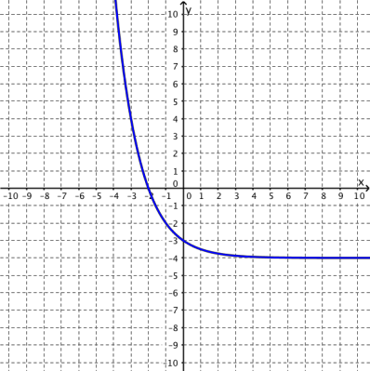

**A** (–4, ∞)

**B** (–3, ∞)

**C** (–∞, –2)

**D** (–∞, –4)

1. The function *f*(*x*) = 1.8*x* + 32 can be used to convert temperatures in degrees Celsius, *x*, into temperatures in degrees Fahrenheit, *f*(*x*). Which function can be used to convert temperatures in degrees Fahrenheit, *x*, into temperatures in degrees Celsius, *f* –1(*x*)?

|  |  |  |  |  |  |
| --- | --- | --- | --- | --- | --- |
| **Temperature, *x* (°C)** | 0 | 10 | 50 | 75 | 100 |
| **Temperature, *f*(*x*) (°F)** | 32 | 50 | 122 | 167 | 212 |

**F** *f* –1(*x*) = 32*x* + 1.8

**G** *f*−1(*x*) = $\frac{32-x}{1.8}$

**H** *f* –1(*x*) = –1.8x – 32

**J** *f*−1(*x*) = $\frac{x-32}{1.8}$

Free Response

1. Generate the inverse of the function represented in the table then determine whether the inverse is also a function.

|  |  |
| --- | --- |
| ***x*** | ***g*(*x*)** |
| –3 | 8 |
| –2 | 4 |
| –1 | 2 |
| 0 | 1 |
| 1 | 0.5 |

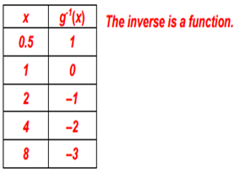

1. Generate the graph of the inverse of the given function. Then determine the *x*-intercept and *y*-intercept of the original function and the *x*-intercept and *y*-intercept of the inverse, if they exist. State whether or not the inverse is also a function.

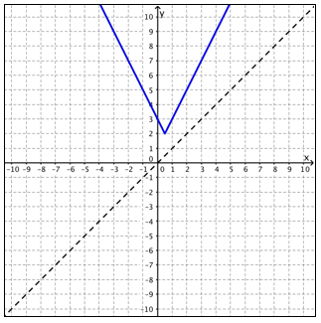

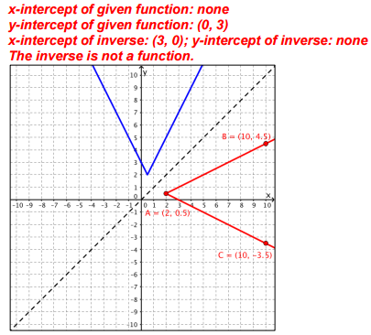

1. If the set {(–6, 7), (–4, –1), (–3, –2), (–1, 2)} represents points on the graph of

*f*(*x*) = (*x* + 3)2 – 2, give a set of points that lie on the graph of the inverse of *f*(*x*).



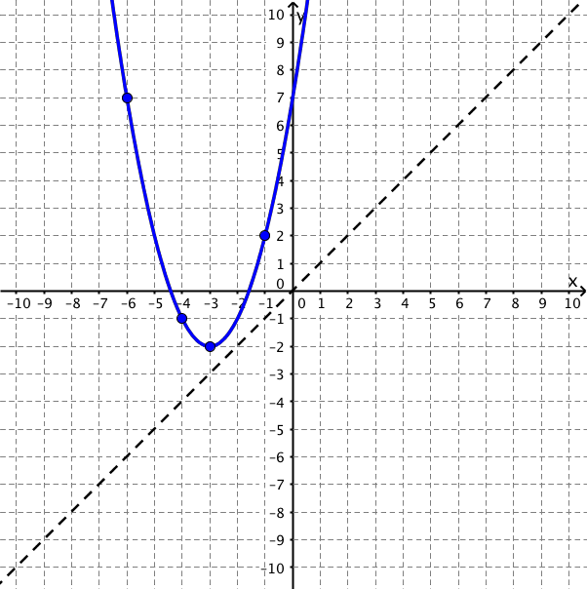

1. A college student invests $200 in a savings bond that pays 5% interest compounded annually. The function that represents the value of the college student’s investment over time is shown in the graph. What is a reasonable range for the inverse of the function shown in the graph? Write the range of the inverse in interval notation.

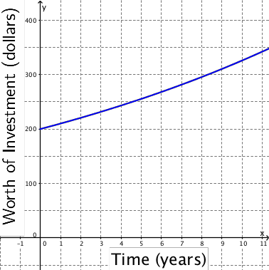



1. The table below represents the functional relationship between braking distance, *f*(*x*), in feet and driving speed in miles per hour under ideal driving conditions. Based on the data table, what is a reasonable domain for the inverse functional relationship between driving speed,

*f* –1(*x*), and braking distance, *x*? Write the domain of the inverse in set builder notation.

|  |  |  |  |  |  |
| --- | --- | --- | --- | --- | --- |
| **Driving Speed, *x* (mph)** | 20 | 40 | 50 | 60 | 80 |
| **Braking Distance, *f*(*x*) (ft)** | 13.4 | 53.5 | 83.6 | 120.4 | 214.1 |



1. Are *f*(*x*) and *g*(*x*) inverses? Explain how you know.

|  |  |  |  |  |
| --- | --- | --- | --- | --- |
| ***x*** | ***f*(*x*)** |  | ***x*** | ***g*(*x*)** |
| 1 | –8 | 7 | 1 |
| 2 | –3 | 2 | 2 |
| 3 | 2 | –3 | 3 |
| 4 | 7 | –8 | 4 |

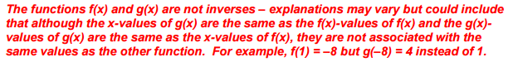

1. Does the graph represent an inverse relationship? Explain your reasoning.

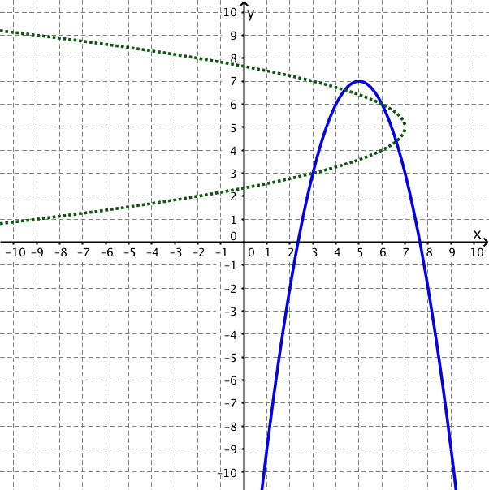



1. Generate *f*−1(*x*), the equation of the inverse of *f*(*x*) = (4*x* + 9) + 3.



1. Generate the square root function that is the inverse of the function *f*(*x*) = 9(*x* – 2)2 with a restricted domain of [2, ).



1. Determine and compare the domain and range as well as any intercepts, if they exist, of the given sets of graphed functions. Write the domain and range as inequalities.

