**Unit 1 Bundle 2: Summative Assessment - KEY**

**Analyzing Algebraic Patterns: Quadratic vs Cubic Functions**

**Use the following situation to answer questions 1 and 2.**

Jamie wants to create a box out of a sheet of cardboard in which the length was 2 inches longer than its width. The height of the box was created by cutting squares from each corner of the cardboard and folding up $\frac{1}{8}$ of the width of the cardboard on all sides as shown in the figure.

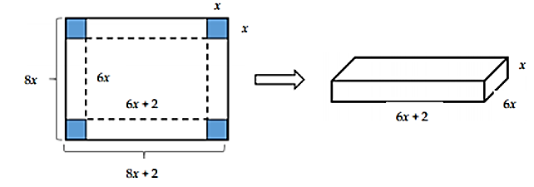

Jamie made several boxes from congruent pieces of cardboard and recorded the surface area of each as compared to the height.

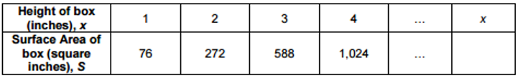

1. Write a function to represent the relationship between $x$ and $S$.



1. What is a reasonable domain and range for the situation?



**Use the following situation to answer questions 3 and 4.**

A shipping company packs chocolate covered almonds in cylindrical cartons with a height 1 inch greater than its radius in inches. Various sizes of the filled cartons and weights are shown in the table below.

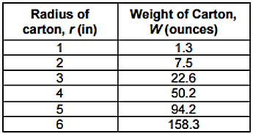

1. Write a function to model the relationship between $r$ and $W$ and determine a reasonable domain and range for the situation.

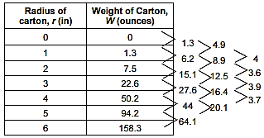



1. According to your model, what would be the approximate height of a carton that weighed about 100 ounces?

