Name: Date: Per:

# Unit 1 Bundle 1: Summative Assessment

**Analyzing Algebraic Patterns: Linear vs Exponential Functions**

Sara has been asked to babysit for a neighbor. She is offered two payment options. With the first plan, she is paid

$5.00 per hour. With the second plan, she is paid $0.25 for one hour, $0.50 for two hours, $1.00 for three hours, and so on, as shown in both the graph and the table.

|  |  |  |
| --- | --- | --- |
| Hours | Plan 1 | Plan 2 |
| 1 | 5.00 | 0.25 |
| 2 | 10.00 | 0.50 |
| 3 | 15.00 | 1.00 |
| 4 |  |  |
| 5 | 25.00 | 4.00 |
| 6 | 30.00 | 8.00 |
| 7 |  |  |
| 8 |  |  |
| 9 |  |  |
| 10 | 50.00 | 128.00 |
| n |  |  |

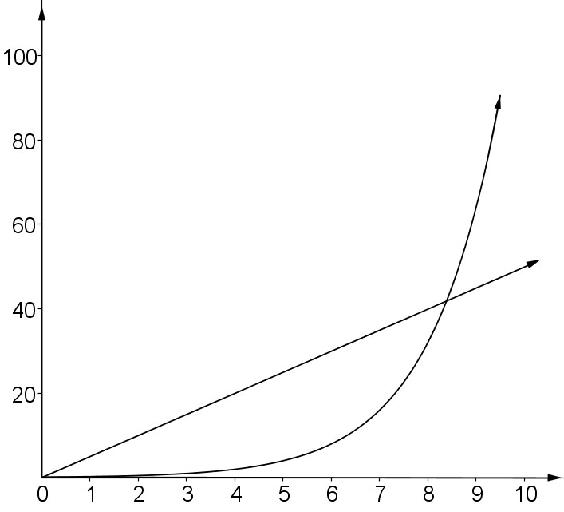

Babysitting Pay

Plan 2

Plan 1

Time (in hours)

Pay (in dollars)

1. What type of function is represented by Plan 1? Complete the table to show the amount of money Sara will make for *n* hours of work.
2. What type of function is represented by Plan 2? Complete the table to show the amount of money Sara will make for *n* hours of work.
3. How are the plans alike? Explain.
4. How are the plans different? Explain.
5. Sara asks you which plan she should choose if she was going to babysit for four hours. What would you tell her? Justify your answer using a complete sentence.
6. When should Sara choose Plan 2? Explain your answer using at least two pieces of evidence.