# Unit 1 Bundle 1: Summative Assessment - KEY

# Analyzing Algebraic Patterns: Linear vs Exponential Functions

Sara has been asked to babysit for a neighbor. She is offered two payment options. With the first plan, she is paid $5.00 per hour. With the second plan, she is paid $0.25 for one hour, $0.50 for two hours, $1.00 for three hours, and so on, as shown in both the graph and the table.

|  |  |  |
| --- | --- | --- |
| Hours | Plan 1 | Plan 2 |
| 1 | 5.00 | 0.25 |
| 2 | 10.00 | 0.50 |
| 3 | 15.00 | 1.00 |
| 4 | **20.00** | **2.00** |
| 5 | 25.00 | 4.00 |
| 6 | 30.00 | 8.00 |
| 7 | **35.00** | **16.00** |
| 8 | **40.00** | **32.00** |
| 9 | **45.00** | **64.00** |
| 10 | 50.00 | 128.00 |
| 𝑛 | 𝟓𝒏 | . 𝟏𝟐𝟓(𝟐)𝒏 |

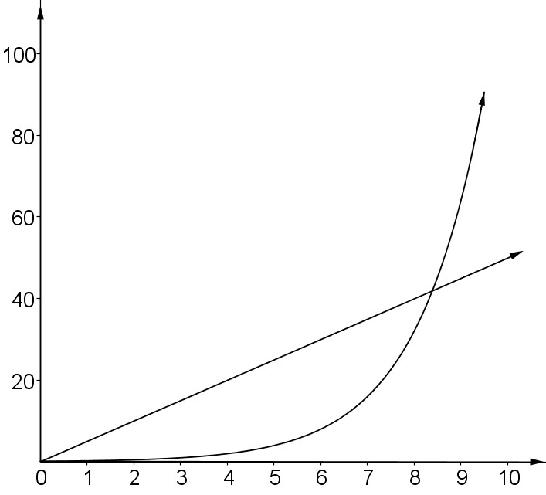

Babysitting Pay

Plan 2

Plan 1

Time (in hours)

Pay (in dollars)

1. What type of function does Plan 1 represent? Complete the table to show the amount of money Sara will make for *n* hours of work. **LINEAR; see Column 1 of table.**
2. What type of function does Plan 2 represent? Complete the table to show the amount of money Sara will make for *n* hours of work. **EXPONENTIAL; see Column 2 of table.**
3. How are the plans alike? Explain.

**Both plans show an INCREASING rate and both start at zero.**

1. How are the plans different? Explain.

**Plan 1 will increase at a constant rate that shows an arithmetic sequence. Plan 2 will increase following a multiplicative rate that shows a geometric sequence (common ratio of 2)**

1. Sara asks you which plan she should choose if she was going to babysit for four hours. What would you tell her? Justify your answer using a complete sentence. **Plan 1 (Linear model) where she would make**

**$20 for four hours of babysitting, but under Plan 2 (Exponential model) she would only make $2 for the same amount of work.**

1. When should Sara choose Plan 2? Explain your answer using at least two pieces of evidence.

**At nine hours and up Plan 2 (Exponential model) will grow at a tremendous rate and be massively higher than Plan 1 (Linear model). Plan 1 increases additively by $5 per hour whereas Plan 2 is doubling each hour, so it becomes more advantageous the more hours you work.**