Algebraic Reasoning

Name:______________________

Per:_____

POINTS:____

Homework #19 Quiz

**Be sure to include your work when appropriate.**

**Describe the transformation of the cubic parent function, f(x) = x3, that will result in the graph of the cubic function given.**

1. g(x) = -3(x)3 + 4

2. g(x) = -(-6x + 5)3 – 3

Algebraic Reasoning

Name:______________________

Per:_____

POINTS:____

Homework #19 Quiz

**Be sure to include your work when appropriate.**

**Describe the transformation of the cubic parent function, f(x) = x3, that will result in the graph of the cubic function given.**

1. g(x) = -3(x)3 + 4

2. g(x) = -(-6x + 5)3 – 3

**Identify the domain, range, relative minimum, relative maximum, x-intercept, and y-intercept of the cubic function described by the equation and the graph. Write the domain and range as intervals.**

4.

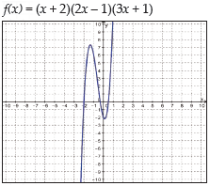

5.

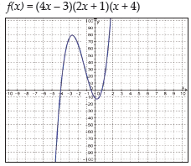

**Identify the domain, range, relative minimum, relative maximum, x-intercept, and y-intercept of the cubic function described by the equation and the graph. Write the domain and range as intervals.**

4.



5.

