Algebraic Reasoning

Name:______________________

Per:_____

POINTS:____

Homework #16 Quiz

**Be sure to include your work when appropriate.**

**Determine whether the set of data represents a linear, exponential, quadratic or cubic function.**

1.

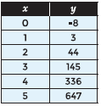

2. **Use finite differences to determine the function that relates the variables.**

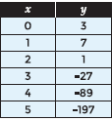

Algebraic Reasoning

Name:______________________

Per:_____

POINTS:____

Homework #16 Quiz

**Be sure to include your work when appropriate.**

**Determine whether the set of data represents a linear, exponential, quadratic or cubic function.**

1.



2. **Use finite differences to determine the function that relates the variables.**



3. Write a function using finite differences that models the data in the table.

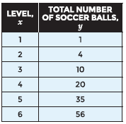

4. What does the range (y-values) of the function represent in the situation?

3. Write a function using finite differences that models the data in the table.



4. What does the range (y-values) of the function represent in the situation?