**Modeling Cubic Functions**

**For questions 1-6, determine whether the set of data represents a linear, exponential, quadratic or cubic function.**

2.

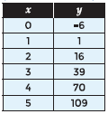

*SOLUTION*:

Δy = 7 Δ2y = 8

Δy = 15 Δ2y = 8

Δy = 23 Δ2y = 8

Δy = 31 Δ2y = 8

Δy = 39

The second finite differences are all 8, so the data represents a quadratic function

*ANSWER*:

Quadratic function

4.

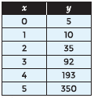

*SOLUTION*:

Δy = 5 Δ2y = 20 Δ3y = 12

Δy = 25 Δ2y = 32 Δ3y = 12

Δy = 57 Δ2y = 44 Δ3y = 12

Δy = 101 Δ2y = 56

Δy = 157

The third finite differences are all 12, so the data represents a cubic function

*ANSWER*:

Cubic function

6.

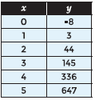

*SOLUTION*:

Δy = 11 Δ2y = 30 Δ3y = 30

Δy = 41 Δ2y = 60 Δ3y = 30

Δy = 101 Δ2y = 90 Δ3y = 30

Δy = 191 Δ2y = 120

Δy = 311

The third finite differences are all 30, so the data represents a cubic function

*ANSWER*:

Cubic function

**For questions 7-12, the data sets shown in the tables represent cubic functions. Use finite differences to determine the function that relates the variables.**

8.

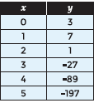

*SOLUTION*:

Δy = 4 Δ2y = -10 Δ3y = -12

Δy = -6 Δ2y = -22 Δ3y = -12

Δy = -28 Δ2y = -34 Δ3y = -12

Δy = -62 Δ2y = -46

Δy = -108

The third finite differences are all -12, so the data represents a cubic function

Δ3y = -12, 6a = -12; a = -2

Δ2y = -10, 6a + 2b = -10; -12 + 2b = -10; 2b = 2; b = 1

Δy = 4, a + b + c = 4; -2 + 1 + c = 4; c = 5

y-int = d = 3

*ANSWER*:

y = -2x3 + 1x2 + 5x + 3

10.

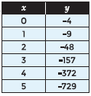

*SOLUTION*:

Δy = -5 Δ2y = -34 Δ3y = -36

Δy = -39 Δ2y = -70 Δ3y = -36

Δy = -109 Δ2y = -106 Δ3y = -36

Δy = -215 Δ2y = -142

Δy = -357

The third finite differences are all -36, so the data represents a cubic function

Δ3y = -36, 6a = -36; a = -6

Δ2y = -34, 6a + 2b = -34; -36 + 2b = -34; 2b = 2; b = 1

Δy = -5, a + b + c = -5; -6 + 1 + c = -5; c = 0

y-int = d = -4

*ANSWER*:

y = -6x3 + x2 - 4

12.

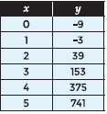

*SOLUTION*:

Δy = 6 Δ2y = 36 Δ3y = 36

Δy = 42 Δ2y = 72 Δ3y = 36

Δy = 114 Δ2y = 108 Δ3y = 36

Δy = 222 Δ2y = 144

Δy = 366

The third finite differences are all 36, so the data represents a cubic function

Δ3y = 36, 6a = 36; a = 6

Δ2y = 36, 6a + 2b = 36; 36 + 2b = 36; 2b = 0; b = 0

Δy = 6, a + b + c = 6; 6 + 0 + c = 6; c = 6

y-int = d = x-9

*ANSWER*:

y = 6x3 - 9

**For questions 13-17, use the following information.**

A box is created from a 20-inch by 24-inch rectangular piece of cardboard by cutting congruent squares from each corner. The squares are cut in 1-inch increments. The resulting sides are folded up and taped to form a rectangular prism (open box). The volume of the box is a function of the side length of the square removed from each corner. The table below relates the volume of the box to the side length of the square.

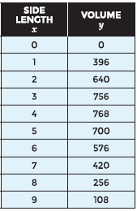

14. What side length of the square produces a tray with the greatest volume?

*SOLUTION*:

Look at the y-values for the largest number, then give the corresponding x-value.

*ANSWER*:

4 inches

**For questions 18 – 22, use the scenario below.**

An employee at a toy store is creating a display of soccer balls in the shape of a tetrahedron, or an equilateral triangle pyramid.

The table below shows the total number of soccer balls at each level of the display, with Level 1 being at the top of the display.

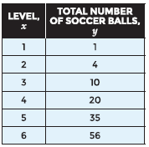

18. Write a function using finite differences that models the data in the table.

*SOLUTION*:

Δy = 1 Δ2y = 2 Δ3y = 1

Δy = 3 Δ2y = 3 Δ3y = 1

Δy = 6 Δ2y = 4 Δ3y = 1

Δy = 10 Δ2y = 5 Δ3y = 1

Δy = 15 Δ2y = 6

Δy = 21

The third finite differences are all 1, so the data represents a cubic function

Δ3y = 1, 6a = 1; a = 1/6

Δ2y = 2, 6a + 2b = 2; 1 + 2b = 2; 2b = 1; b = 1/2

Δy = 1, a + b + c = 1; 1/6 + 1/2 + c = 1; c = 1/3

y-int = d = 0

*ANSWER*:

y = x3 + x2 + x

20. What does the range (y-values) of the function represent in the situation?

*ANSWER*:

The total number of soccer balls

22. How many soccer balls would be needed to build a display 10 levels high?

*SOLUTION*:

Make a table of the function, y = x3 + x2 + x and look at where the x-value is 10.

*ANSWER*:

220 soccer balls