**Writing Cubic Functions** Δ2y =

**For questions 1-6, determine whether the set of data represents a linear, exponential, quadratic, or cubic function.**

2.

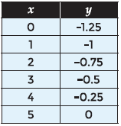

*SOLUTION*:

Δy = .25

Δy = .25

Δy = .25

Δy = .25

Δy = .25

The first finite differences are all .25, so the data represents a linear function

*ANSWER*:

Linear function

4.

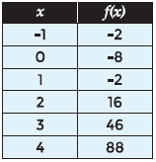

*SOLUTION*:

Δy = -6 Δ2y = 12

Δy = 6 Δ2y = 12

Δy = 18 Δ2y = 12

Δy = 30 Δ2y = 12

Δy = 42 Δ2y = 12

The second finite differences are all 12, so the data represents a quadratic function

*ANSWER*:

Quadratic function

6.

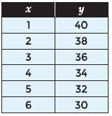

*SOLUTION*:

Δy = -2

Δy = -2

Δy = -2

Δy = -2

Δy = -2

The first finite differences are all -2, so the data represents a linear function

*ANSWER*:

Linear function

**For questions 8-10, determine if the given relationship is a cubic function. If it is, write a function relating the variables.**

8.

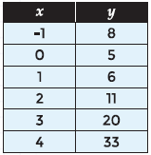

*SOLUTION*:

Δy = -3 Δ2y = 4

Δy = 1 Δ2y = 4

Δy = 5 Δ2y = 4

Δy = 9 Δ2y = 4

Δy = 13

The second finite differences are all 4, so the data represents a quadratic function

*ANSWER*:

Not a cubic function

10.

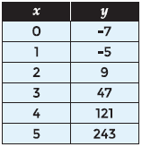

*SOLUTION*:

Δy = 2 Δ2y = 12 Δ3y = 12

Δy = 14 Δ2y = 24 Δ3y = 12

Δy = 38 Δ2y = 36 Δ3y = 12

Δy = 74 Δ2y = 48

Δy = 122

The third finite differences are all 12, so the data represents a quadratic function

Δ3y = 12, 6a = 12; a = 2

Δ2y = 12, 6a + 2b = 12; 12 + 2b = 12; b = 0

Δy = 2, a + b + c = 2; 2 + 0 + c = 2; c = 0

y-int = d = -7

*ANSWER*:

y = 2x2 - 7

**For questions 11-16, the data sets shown in the tables represent cubic functions. Write a cubic function for the values in the table.**

12.

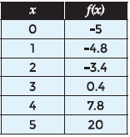

*SOLUTION*:

Δy = 0.2 Δ2y = 1.2 Δ3y = 1.2

Δy = 1.4 Δ2y = 2.4 Δ3y = 1.2

Δy = 3.8 Δ2y = 3.6 Δ3y = 1.2

Δy = 7.4 Δ2y = 4.8

Δy = 12.2

The third finite differences are all 1.2, so the data represents a cubic function

Δ3y = 1.2, 6a = 1.2; a = 0.2

Δ2y = 1.2, 6a + 2b = 1.2; 1.2 + 2b = 1.2; b = 0

Δy = 0.2, a + b + c = 0.2; 0.2 + 0 + c = 0.2; c = 0

y-int = d = -5

*ANSWER*:

y = 0.2x2 - 5

14.

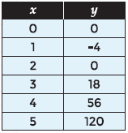

*SOLUTION*:

Δy = -4 Δ2y = 8 Δ3y = 6

Δy = 4 Δ2y = 14 Δ3y = 6

Δy = 18 Δ2y = 20 Δ3y = 6

Δy = 38 Δ2y = 26

Δy = 64

The third finite differences are all 6, so the data represents a cubic function

Δ3y = 6, 6a = 6; a = 1

Δ2y = 8, 6a + 2b = 8; 6 + 2b = 8; 2b = 2; b = 1

Δy = -4, a + b + c = -4; 1 + 1 + c = -4; c = -6

y-int = d = 0

*ANSWER*:

y = x3 + x2 – 6x

16.

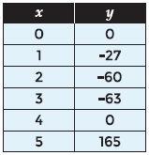

*SOLUTION*:

Δy = -27 Δ2y = -6 Δ3y = 36

Δy = -33 Δ2y = 30 Δ3y = 36

Δy = -3 Δ2y = 66 Δ3y = 36

Δy = 63 Δ2y = 102

Δy = 165

The third finite differences are all 36, so the data represents a cubic function

Δ3y = 36, 6a = 36; a = 6

Δ2y = -6, 6a + 2b = -6; 36 + 2b = -6; 2b = -42; b = -21

Δy = -27, a + b + c = -27; 6 - 21 + c = -27; -15 + c = -27

c = -12

y-int = d = 0

*ANSWER*:

y = 6x3 – 21x2 – 12x

A local mail service charges different rates, based on the weight of the packages mailed. A sample of their prices is shown in the table below.

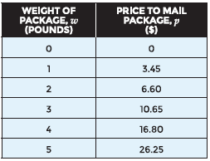

20. Use a cubic function to determine the cost to mail a 6-pound package.

*SOLUTION*:

Δy = 3.45 Δ2y = -0.3 Δ3y = 1.2

Δy = 3.15 Δ2y =0.9 Δ3y = 1.2

Δy = 4.05 Δ2y = 2.1 Δ3y = 1.2

Δy = 6.15 Δ2y = 3.3

Δy = 9.45

The third finite differences are all 1.2, so the data represents a cubic function

Δ3y = 1.2, 6a = 1.2; a = 0.2

Δ2y = -0.3, 6a + 2b = -0.3; 1.2 + 2b = -0.3; 2b = -1.5;

b = -0.75

Δy = 3.45, a + b + c = 3.45; 0.2 – 0.75 + c = 3.45;

-0.55+ c = 3.45;

c = 4

y-int = d = 0

y = 0.2x3 – 0.75x2 + 4x

Input 6 for x

y = 0.2(6)3 – 0.75(6)2 + 4(6)

*ANSWER*:

y = $40.20