Algebraic Reasoning

Name:______________________

Per:_____

POINTS:____

Homework #12 Quiz

**Be sure to include your work when appropriate.**

**Calculate the average ratio between successive y-values.**

1.

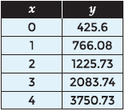

2.

**identify whether the data shows exponential growth or exponential decay. Then determine an exponential function to model the situation.**

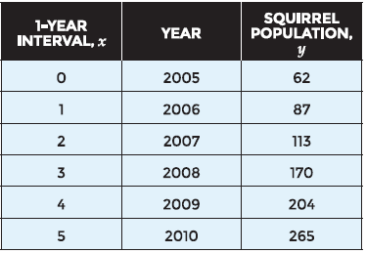

Algebraic Reasoning

Name:______________________

Per:_____

POINTS:____

Homework #12 Quiz

**Be sure to include your work when appropriate.**

**Calculate the average ratio between successive y-values.**

1.



2.

**identify whether the data shows exponential growth or exponential decay. Then determine an exponential function to model the situation.**



**Use the data set to generate an exponential**

**model.**

3.

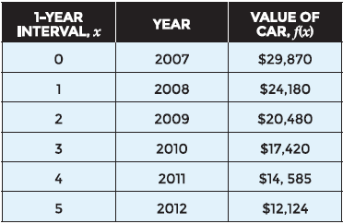

4.

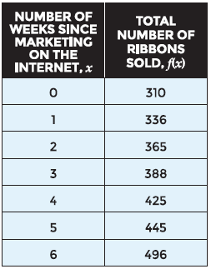

**Use the data set to generate an exponential**

**model.**

3.



4.

