**Writing Exponential Functions**

**For questions 3-5, calculate the average ratio between successive y-values.**

3.

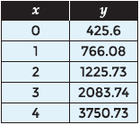

*SOLUTION*:

$\frac{yn }{yn-1}$ = $\frac{766.08}{425.6}$ = 1.8

$\frac{yn }{yn-1}$ = $\frac{1225.73}{766.08}$ = 1.7

$\frac{yn }{yn-1}$ = $\frac{2083.74}{1225.73}$ = 1.6

$\frac{yn }{yn-1}$ = $\frac{3750.73}{2083.74}$ = 1.8

$\frac{1.8+1.7+1.6+1.8 }{4}$ = 1.725

*ANSWER*:

1.725

4.



*SOLUTION*:

$\frac{yn }{yn-1}$ = $\frac{1173.31}{2300.6}$ = .51

$\frac{yn }{yn-1}$ = $\frac{586.65}{1173.31}$ = .5

$\frac{yn }{yn-1}$ = $\frac{287.46}{586.65}$ = .49

$\frac{yn }{yn-1}$ = $\frac{137.98}{287.46}$ = .48

$\frac{yn }{yn-1}$ = $\frac{70.37}{137.98}$ = .51

$\frac{yn }{yn-1}$ = $\frac{36.59}{70.37}$ = .52

$\frac{.51+.5+.49+.48+.51+.52 }{6}$ = .502

*ANSWER*:

.502

5.



*SOLUTION*:

$\frac{yn }{yn-1}$ = $\frac{2172}{1810.4}$ = 1.2

$\frac{yn }{yn-1}$ = $\frac{2389.2}{2172}$ = 1.1

$\frac{yn }{yn-1}$ = $\frac{3105.96}{2389.2}$ = 1.3

$\frac{yn }{yn-1}$ = $\frac{3727.15}{3105.96}$ = 1.2

$\frac{1.2+1.1+1.3+1.2 }{4}$ = 1.2

*ANSWER*:

1.2

**For questions 6-8, identify whether the data shows exponential growth or exponential decay. Then determine an exponential function to model the situation.**

6. The population of gray squirrels in a local park has been recorded every year since 2005.

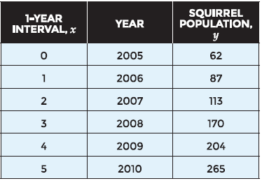

*SOLUTION*:

The data shows exponential growth since the y-values are increasing

$\frac{yn }{yn-1}$ = $\frac{87}{62}$ = 1.4

$\frac{yn }{yn-1}$ = $\frac{113}{87}$ = 1.3

$\frac{yn }{yn-1}$ = $\frac{170}{113}$ = 1.5

$\frac{yn }{yn-1}$ = $\frac{204}{170}$ = 1.2

$\frac{yn }{yn-1}$ = $\frac{265}{204}$ = 1.3

$\frac{1.4+1.3+1.5+1.2+1.3 }{5}$ = 1.34

When x = 0, y = 62

*ANSWER*:

y = 62(1.34)x

**7**. Kristal noticed that her favorite painting in a museum has been increasing in value over the years. The changing value of the painting is shown in the table.

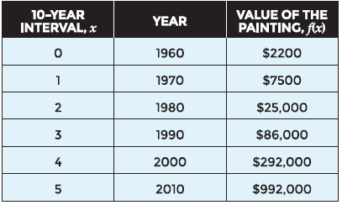

*SOLUTION*:

The data shows exponential growth since the y-values are increasing

$\frac{yn }{yn-1}$ = $\frac{7500}{2200}$ = 3.41

$\frac{yn }{yn-1}$ = $\frac{25000}{7500}$ = 3.33

$\frac{yn }{yn-1}$ = $\frac{86000}{25000}$ = 3.44

$\frac{yn }{yn-1}$ = $\frac{292000}{86000}$ = 3.4

$\frac{yn }{yn-1}$ = $\frac{992000}{292000}$ = 3.4

$\frac{3.41+3.33+3.44+3.4+3.4 }{5}$ = 3.4

When x = 0, y = 2200

*ANSWER*:

y = 2200(3.4)x

8. Mrs. Montgomery’s class is doing an experiment with pennies. They empty a cup of pennies onto a table, and remove all the pennies that landed “heads up.” Then, they put the other pennies back in the cup, and repeat the process four more times.

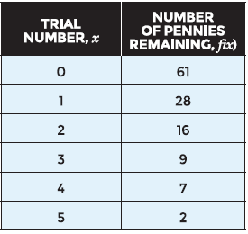

*SOLUTION*:

The data shows exponential decay since the y-values are decreasing

$\frac{yn }{yn-1}$ = $\frac{28}{61}$ = .459

$\frac{yn }{yn-1}$ = $\frac{16}{28}$ = .571

$\frac{yn }{yn-1}$ = $\frac{9}{16}$ = .563

$\frac{yn }{yn-1}$ = $\frac{7}{9}$ = .78

$\frac{yn }{yn-1}$ = $\frac{2}{7}$ = .286

$\frac{.459+.571+.563+.78+.286 }{5}$ = .53

When x = 0, y = 61

*ANSWER*:

y = 61(.53)x

**For questions 9-12 use the following situation.**

Most cars decrease in value over time. The table below shows the value of Carla’s car from the time of its purchase.

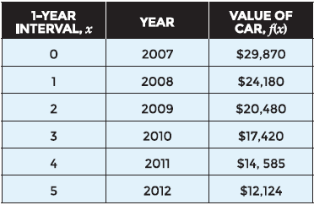

9. Use the data set to generate an exponential model.

*SOLUTION*:

$\frac{yn }{yn-1}$ = $\frac{24180}{29870}$ = .81

$\frac{yn }{yn-1}$ = $\frac{20480}{24180}$ = .85

$\frac{yn }{yn-1}$ = $\frac{17420}{20480}$ = .85

$\frac{yn }{yn-1}$ = $\frac{14585}{17420}$ = .84

$\frac{yn }{yn-1}$ = $\frac{12124}{14585}$ = .83

$\frac{.81+.85+.85+.84+.83 }{5}$ = .84

When x = 0, y = 29870

*ANSWER*:

y = 29870(.84)x

10. What do the y-intercept and base from your function rule mean in context of the situation?

*ANSWER*:

The y-intercept is the value of the car when Carla bought it

The base from the rule is the percentage of the value of the car from the previous year

12. Use your model to predict the value of Carla’s car in the year 2020?

S*OLUTION*:

y = 29870(.84)x

y = 29870(.84)13

y = 3096

*ANSWER*:

$3096

**For questions 13-16 use the following situation.**

Ella sells hair ribbons and decided to start marketing them on the internet hoping to increase her sales. The table shows the total number of ribbons she has sold.

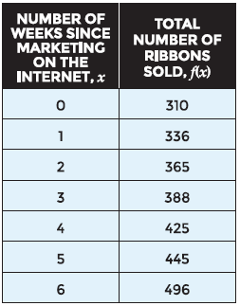

13. Use the data set to determine an exponential function that models the situation.

*SOLUTION*:

$\frac{yn }{yn-1}$ = $\frac{336}{310}$ = 1.08

$\frac{yn }{yn-1}$ = $\frac{365}{336}$ = 1.09

$\frac{yn }{yn-1}$ = $\frac{388}{365}$ = 1.06

$\frac{yn }{yn-1}$ = $\frac{425}{388}$ = 1.1

$\frac{yn }{yn-1}$ = $\frac{445}{425}$ = 1.05

$\frac{yn }{yn-1}$ = $\frac{496}{445}$ = 1.11

$\frac{1.08+1.09+1.06+1.1+1.05+1.11 }{6}$ = 1.08

When x = 0, y = 310

*ANSWER*:

y = 310(1.08)x

14. What is the y-intercept of this function, and what does it mean in this problem?

*ANSWER*:

the y-intercept, 310, is the number of ribbons sold before marketing on the internet

16. Use your function model to predict how many ribbons Ella will sell in a year.

*SOLUTION*:

y = 310(1.08)x

y = 310(1.08)52

y = 16,959

*ANSWER*:

16,959 ribbons