Algebraic Reasoning

Name:______________________

Per:_____

POINTS:____

Homework #10 Quiz

**Be sure to include your work when appropriate.**

**For the following sets of data, calculate the average finite difference, and use that to determine the slope of a linear function that could model the data.**

1.

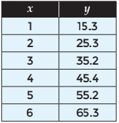

2.



Algebraic Reasoning

Name:______________________

Per:_____

POINTS:____

Homework #10 Quiz

**Be sure to include your work when appropriate.**

**For the following sets of data, calculate the average finite difference, and use that to determine the slope of a linear function that could model the data.**

1.



2.



Charlie is measuring his little brother’s height throughout the year to see how much he grows. The table below shows how his height changes during the first 5 months.

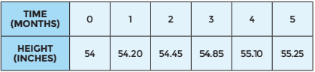

3. Write a function rule to model the situation.

Jeff noticed that the nutrition information on his box of cereal states that there are 14 servings in the cereal box. He decided to put their claim to the test. He recorded the weight of the remaining cereal after each serving, as shown in the table below.

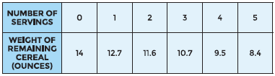

4. Write a function rule that models the situation.

Charlie is measuring his little brother’s height throughout the year to see how much he grows. The table below shows how his height changes during the first 5 months.



3. Write a function rule to model the situation.

Jeff noticed that the nutrition information on his box of cereal states that there are 14 servings in the cereal box. He decided to put their claim to the test. He recorded the weight of the remaining cereal after each serving, as shown in the table below.



4. Write a function rule that models the situation.