Algebraic Reasoning

Name:______________________

Per:_____

POINTS:____

Classwork #12 Quiz

**Be sure to include your work when appropriate.**

**Use finite differences if the data set represents linear, exponential, quadratic, or other type function**.

1.

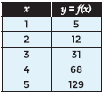

**Use finite differences to determine the values a, b, and c and then write the function in standard form.**

2.

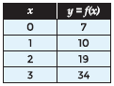

Algebraic Reasoning

Name:______________________

Per:_____

POINTS:____

Classwork #12 Quiz

**Be sure to include your work when appropriate.**

**Use finite differences if the data set represents linear, exponential, quadratic, or other type function**.

1.



**Use finite differences to determine the values a, b, and c and then write the function in standard form.**

2.



**Use finite differences to determine f(0), the values a, b, and c and then write the function in standard form.**

3.

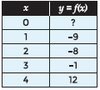

4.

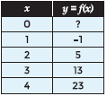

**Use finite differences to determine f(0), the values a, b, and c and then write the function in standard form.**

3.



4.

