**12-1 Study Guide and Intervention**

***Linear and Nonlinear Functions***

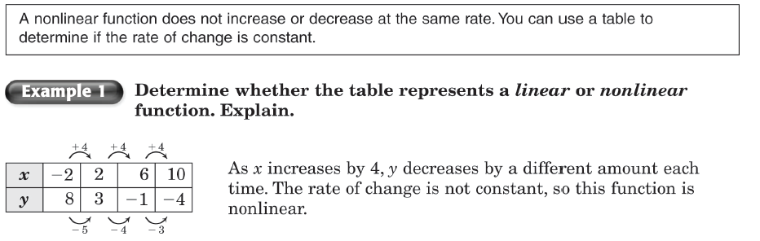

**Exercises**

**Determine whether the table represents a *linear* or *nonlinear* function. If it is linear, write the equation for the function.**

**1. 2. 3.**

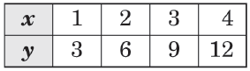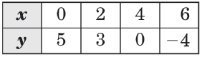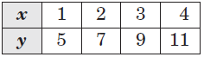

**4. 5. 6.**

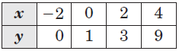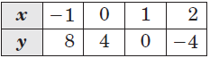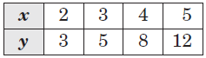

**7. 8. 9.**

