**Study Guide and Intervention**

***Exponential Functions***

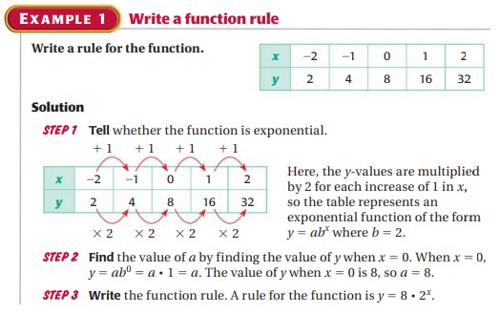

**Exercises**

**Write the equation for the function.**

**1. 2. 3.**

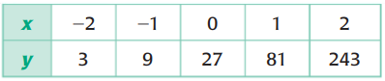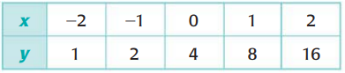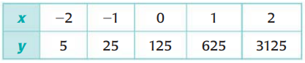

**4. 5. 6.**

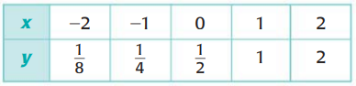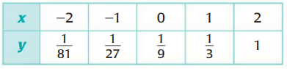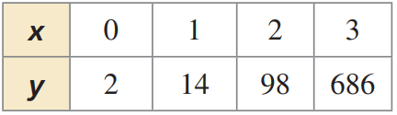

**7. 8. 9.**

