Algebraic Reasoning

Name:______________________

Per:_____

POINTS:____

Classwork #14 Quiz

**Be sure to include your work when appropriate.**

**Use finite differences to determine if the data sets represent linear, exponential, quadratic, or other type of function.**

1.

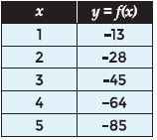

**Use the data set to generate a quadratic**

**function that best models the data.**

2.

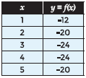

Algebraic Reasoning

Name:______________________

Per:_____

POINTS:____

Classwork #14 Quiz

**Be sure to include your work when appropriate.**

**Use finite differences to determine if the data sets represent linear, exponential, quadratic, or other type of function.**

1.



**Use the data set to generate a quadratic**

**function that best models the data.**

2.



**For questions 3 and 4, use the following information.**

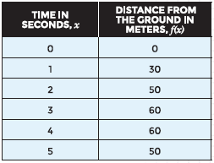

3. Use the data in the table to generate a quadratic function that models the data.

**4.** Use the data in the table to find the height of the ball after 7 seconds.

**For questions 3 and 4, use the following information.**



3. Use the data in the table to generate a quadratic function that models the data.

**4.** Use the data in the table to find the height of the ball after 7 seconds.