**3-3 Study Guide and Intervention**

***Slopes of Lines***

**Exercises**

**Determine the slope of the line that contains the given points.**

**1.** *J*(0, 0), *K*(–2, 8) **2.** *R*(–2, –3), *S*(3, –5)

**3.** *L*(1, –2), *N*(–6, 3) **4.** *P*(–1, 2), *Q*(–9, 6)

**5.** *T*(1, –2), *U*(6, –2) **6.** *V*(–2, 10), *W*(–4, –3)

**Find the slope of each line.**

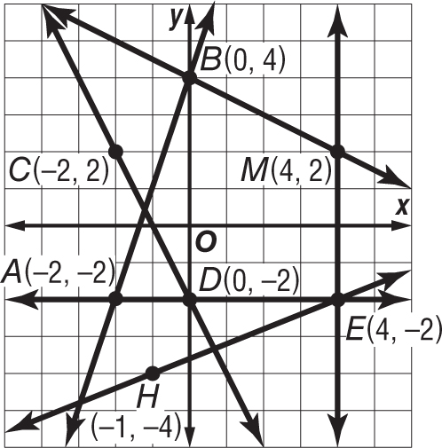 **7. $\overset{⃡}{AB}$**  **8. $\overset{⃡}{CD}$**

**9. $\overset{⃡}{EM}$**  **10. $\overset{⃡}{AE}$**

**11. $\overset{⃡}{EH}$**  **12. $\overset{⃡}{BM}$**

**Exercises**

**Determine whether $\overset{⃡}{MN}$ and $\overset{⃡}{RS}$ are *parallel*, *perpendicular*, or *neither*. Graph each line to verify your answer.**

**13.** *M*(0, 3), *N*(2, 4), *R*(2, 1), *S*(8, 4) **14.** *M*(–1, 3), *N*(0, 5), *R*(2, 1), *S*(6, –1)

**15.** *M*(–1, 3), *N*(4, 4), *R*(3, 1), *S*(–2, 2) **16.** *M*(0, –3), *N*(–2, –7), *R*(2, 1), *S*(0, –3)

**Graph the line that satisfies each condition.**

**17.** slope = 4, passes through (6, 2)

**18.** passes through *H*(8, 5), perpendicular to $\overset{⃡}{AG}$ with *A*(–5, 6) and *G*(–1, –2)

**19.** passes through *C*(–2, 5), parallel to $\overset{⃡}{LB}$ with *L*(2, 1) and *B*(7, 4)

**3-4 Study Guide and Intervention**

***Equations of Lines***

**Exercises**

**Write an equation in slope-intercept form of the line having the given slope and *y*-intercept or given points.   
Then graph the line.**

**1.** *m*: 2, *b*: –3 **2.** *m*: – $\frac{1}{2}$*b*: 4

**3.** *m*: $\frac{1}{4}$, *b*: 5 **4.** *m*: 0, *b*: –2

**Write an equation in point-slope form of the line having the given slope that contains the given point.   
Then graph the line.**

**5.** *m* = $\frac{1}{2}$, (3, –1) **6.** *m* = –2, (4, –2)

**7**. *m* = –1, (–1, 3) **8.** *m* = $\frac{1}{4}$, (–3, –2)

**Exercises**

**For Exercises 9-12, use the following information.**

Jerri’s current satellite television service charges a flat rate of $34.95 per month for the basic channels and an additional $10 per month for each premium channel. A competing satellite television service charges a flat rate of $39.99 per month for the basic channels and an additional $8 per month for each premium channel.

**9.** Write an equation in slope-intercept form that models the total monthly cost for each satellite service, where *p* is the number of premium channels.

**11.** A third satellite company charges a flat rate of $69 for all channels, including the premium channels. If Jerri wants to add a fourth premium channel, which service would be least expensive?

**10.** If Jerri wants to include three premium channels in her package, which service would be less, her current service or the competing service?

**12.** Write a description of how the fee for the number of premium channels is reflected in the equation.