**3-1 Study Guide and Intervention**

***Parallel Lines and Transversals***

**Exercises**

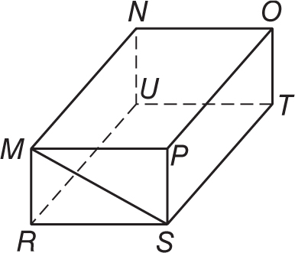**Refer to the figure at the right to identify each of the following.**

**1.** all planes that intersect plane *OPT*

**2.** all segments parallel to $\overline{NU}$

**3.** all segments that intersect $\overline{MP}$

**Refer to the figure at the right to identify each of the following.**

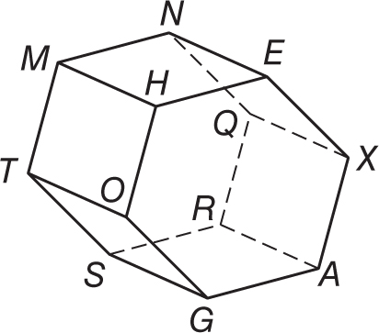 **4.** all segments parallel to $\overline{QX}$

**5.** all planes that intersect plane *MHE*

**6.** all segments parallel to $\overline{QR}$

**7.** all segments skew to $\overline{AG}$

**Exercises**

**Classify the relationship between each pair of angles as *alternate interior*, *alternate exterior*, *corresponding*, or *consecutive interior* angles.**

**8.** ∠1 and ∠5 **9.** ∠6 and ∠14 **10.** ∠2 and ∠8

**11.** ∠3 and ∠11 **12.** ∠12 and ∠3 **13.** ∠4 and ∠6

**14.** ∠6 and ∠16 **15.** ∠11 and ∠14 **16.** ∠10 and ∠16

**3-2 Study Guide and Intervention**

***Angles and Parallel Lines***

**Exercises**

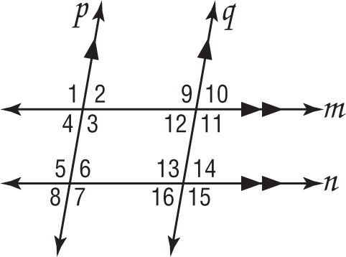**In the figure, *m*∠3 = 102. Find the measure of each angle.**

**Tell which postulate(s) or theorem(s) you used.**

**1.** ∠5 **2.** ∠6

**3.** ∠11 **4.** ∠7

**5.** ∠15 **6.** ∠14

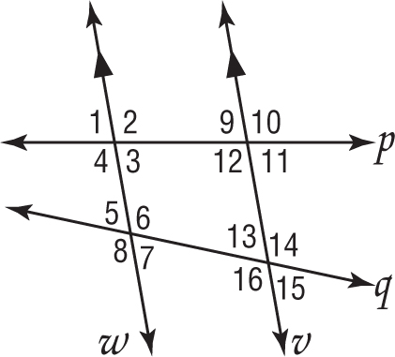**In the figure, *m*∠9 = 80 and *m*∠5 = 68. Find the measure**

**of each angle. Tell which postulate(s) or theorem(s) you used.**

**7.** ∠12 **8.** ∠1

**9.** ∠4 **10.** ∠3

**11.** ∠7 **12.** ∠16

**Exercises**

**Find the value of the variable(s) in each figure. Explain your reasoning.**

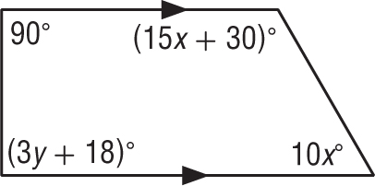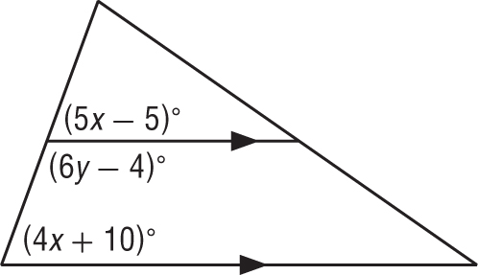 **13. 14.**

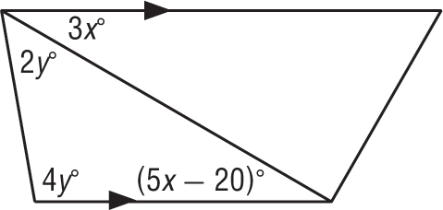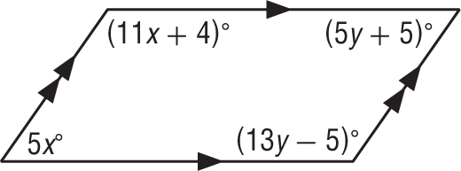 **15. 16.**